 | 
COUNCIL ASSESSMENT REPORT
WESTERN REGIONAL PLANNING PANEL

PANEL REFERENCE & DA NUMBER | PPSWES-318 – DA154/25
PROPOSAL | Electricity generating facility (solar and wind)
ADDRESS | Lot 1 DP1031694, 43 Hampton Road, Hampton NSW 2790
APPLICANT | Angus Witherby on behalf of Windfarm 1 PTY LTD
OWNER | Windfarm 1 PTY LTD
DA LODGEMENT DATE | 3 October 2025
APPLICATION TYPE | Concurrence Development Application
REGIONALLY SIGNIFICANT CRITERIA | The proposed development is for electricity generating works with an estimated development cost of more than $5m; therefore, it is regionally significantly development pursuant to clause 5(a) of Schedule 6 of State Environmental Planning Policy (Planning Systems) 2021.
CIV | $12,700.00 (Including GST as per Clause 208(4) of the Environmental Planning and Assessment Regulation 2021).
CLAUSE 4.6 REQUESTS | N/A.
KEY SEPP/LEP | Environmental planning instruments  In determining the development application, the following environmental planning instruments will be considered pursuant to s 4.15(1)(a)(i) of the Environmental Planning & Assessment Act 1979:  - State Environmental Planning Policy (Planning Systems) 2021,  - State Environmental Planning Policy (Biodiversity & Conservation) 2021,  - Protection of the Environment Operations Act 1997,  - State Environmental Planning Policy (Resilience & Hazards) 2021,  - State Environmental Planning Policy (Transport and Infrastructure) 2021,  - Lithgow Local Environmental Plan 2014 (LLEP2014)  Development control plan  In determining the development application, the following development control plan will be considered pursuant to s 4.15(1)(a)(iii) of the Environmental Planning & Assessment Act 1979:  - Lithgow City Development Control Plan 2021  Contributions plan  The Lithgow City Council Local Infrastructure Contributions Plan (Section 7.12) 2024-2026 applies to the development proposal.
TOTAL & UNIQUE SUBMISSIONS KEY ISSUES IN SUBMISSIONS | The development was publicly notified in accordance with the Lithgow Community Participation Plan 2020 (CPP) and the provisions of Environmental Planning and Assessment Regulations 2021 (EP&A Regulation). The notification period was for a minimum of 28 days (extended for an additional 7 days) from 17 October 2025 to 21 November 2025.  During the notification period ninety six (96) submissions were received by way of objection and three (3) submissions were received in support. Additionally, two submissions were received from neighboring Councils.  The key issues involve:  - Inadequate Documentation,  - Noise and Vibration,  - Visual and Amenity Impacts,  - Tourism Impacts,  - Health and Safety Impacts,  - Legislation Requirements,  - Decommissioning, Rehabilitation and Waste Impacts,  - Biodiversity and Ecological Impacts,  - Benefits and Economic Impacts,  - Property and Business Devaluation,  - Transmission Line Location and Grid Capacity,  - Heritage and Indigenous Impacts,  - Limited Consultation and Transparency with the community,  - Traffic Impacts,  - Current Turbine Issues.
DOCUMENTS SUBMITTED FOR CONSIDERATION | - General Specification; Vestas, dated 24 September 2024,  - Noise and Vibration Assessment Report; SLR Consulting Australia, dated 10 April 2025,  - Site Plan; Wakefield Planning, dated 16 February 2025,  - Survey Plan; CEH Survey, dated March 2025,  - Statement of Environmental Effects; Wakefield Planning, 23 September 2025,  - Traffic Route Study; Rex J Andrews Engineered Transportation, 7 April 2025,  - Visual Assessment Report; Wakefield Planning, 18 April 2025.
SPECIAL INFRASTRUCTURE CONTRIBUTIONS (S7.24) | The site is not located in an area that Special Infrastructure Contributions (SIC) apply.
RECOMMENDATION | REFUSAL
DRAFT CONDITIONS TO APPLICANT | Not Applicable
SCHEDULED MEETING DATE | 22 September 2026
PREPARED BY | Lauren Stevens-Development Planner; Lithgow City Council
DATE OF REPORT | 8 September 2026

EXECUTIVE SUMMARY
Angus Witherby on behalf of Windfarm 1 PTY LTD (the Applicant) has lodged a development application, number DA154/25, for the development of a electricity generating facility on land known as Lot 1 DP1031694, 43 Hampton Road, Hampton.

The application is seeking consent for the decommissioning and removal of the existing two wind turbines and construction and assembly of two new wind turbines.

By way of background, on 18 September 2000, development consent was issued for the construction of a wind farm involving two turbines (660kW) on the property (DA96/01). The application has indicated that these turbines are now near the end of their economic life and needs replacing and upgrading.

The new turbines are proposed to have the following specifications:
- Height (total)- 120m
- Rotor Diameter- 80m
- Blade Length- 39m
- No. of Blades- 3 each
- Hub Height- 80m
- Capacity of 2 megawatts

The turbines are proposed to be larger than the existing turbines that would extend the economic life and power output.

It is expected that the new turbines may have a future lifespan of 30-40 years.

The location of the proposed turbines would be closer to the north and west boundary of the allotment. This would have the blades overhanging over the adjoining property of Lot 2 DP1031694. The owner of Lot 2 has granted consent to the lodgement of the development application and acknowledges the overhang of the blades and near boundary impacts.

The site is located in the RU1 – Primary Production zone pursuant to Clause 2.2 of the Lithgow Local Environmental Plan 2014 (‘LEP 2014’). Electricity generating facilities are permissible with consent in the RU1 zone as per the State Environmental Planning Policy (Transport and Infrastructure) 2021.

The principle local planning controls relevant to the proposal include the Lithgow Local Environmental Plan 2014 and the Lithgow Development Control Plan 2021.

The development is not defined as being ‘integrated development’ under Section 4.46 of the Environmental Planning and Assessment Act (EP&A Act) 1979, ‘state significant development’ under Section 4.36 of the Environmental Planning and Assessment Act (EP&A Act) 1979, or designated development under Section 4.10 of the Environmental Planning and Assessment Act (EP&A Act) 1979. Under Schedule 3 of the Environmental Planning and Assessment Regulation 2021, electricity generating stations are classified as designated development where they supply or capable of supplying more than 30 megawatts of electrical power from other energy sources. The development is for a 2 megawatt facility.

The development was referred to WaterNSW as a concurrence authority as per Section 4.13 of the EP&A Act 1979, and Endeavour Energy under Section 2.48 – State Environmental Planning Policy (Transport and Infrastructure) 2021 Development Applications-Other Development.

The development was further referred to the Department of Climate Change, Energy, the Environment and Water, Transport for NSW, Environmental Protection Authority, NSW Police, Nepean Blue Mountains Health, Civil Aviation Safety Authority as general notification referrals for advice.

The development is defined as being ‘Regional Development” as per Clause 5(b) Schedule 6 of the State Environmental Planning Policy (Planning Systems) 2021 (PS SEPP) – Private infrastructure and community facilities over $5 million: development is for electricity generating works. As such, the Western Regional Planning Panel (the Panel) is the consent authority for the application.

The main planning instruments, approvals and guidelines that are relevant to the proposal include:
- State Environmental Planning Policy (Planning Systems) 2021,
- State Environmental Planning Policy (Biodiversity & Conservation) 2021,
- Protection of the Environment Operations Act 1997,
- State Environmental Planning Policy (Resilience & Hazards) 2021,
- State Environmental Planning Policy (Transport and Infrastructure) 2021,
- Lithgow Local Environmental Plan 2014 (LLEP2014)
- The Lithgow Development Control Plan 2021, and
- Wind Energy Guideline November 2024, Department of Planning, Housing and Infrastructure.

Several pre-conditions/jurisdictional prerequisites are required to be satisfied before the granting of consent. These are listed in the following table and are considered to have been satisfactorily addressed by the documentation submitted.

State Environmental  Planning Policy  (Biodiversity &  Conservation) 2021 | Chapter 6: Water Catchments  - Clause 6.64 - provides that the concurrence of the Regulatory Authority is required.
State Environmental Planning Policy (Planning Systems) 2021 | Schedule 6: Regionally Significant Development  - Clause 5 - Private infrastructure and community facilities over $5 million: development is for electricity generating works.
State Environmental Planning Policy (Transport and Infrastructure) 2021 | Division 4 Electricity generating works or solar energy systems  - Clause 2.36 - Development permitted with consent  (1) Development for the purpose of electricity generating works may be carried out by any person with consent on the following land—  (a) in the case of electricity generating works comprising a building or place used for the purpose of making or generating electricity using waves, tides or aquatic thermal as the relevant fuel source—on any land,
Protection of the Environment Operations Act 1997 | Chapter 3 Environment protection licences  - Clause 43 - Types of licences  Environment protection licences may be issued for the following purposes—  (b) to authorise the carrying out of scheduled activities at any premises, as required under section 48,  - Clause 48 - Licensing requirement—scheduled activities (premises-based)  (1) Application of section This section applies to scheduled activities where Schedule 1 indicates that a licence is required for premises at which the activity is carried on.  Schedule 1 Scheduled activities  1 Application of Part  For the purposes of section 48, any activity that is declared by this Part to be a scheduled activity is taken to be an activity for which a licence is required for the premises at which it is carried out (the activity is premises-based).  17 Electricity generation  (1) This clause applies to the following activities—  electricity works (wind farms), meaning the generation of electricity by means of wind turbines.  The application was referred to EPA who advised the following:  The EPA does not have any comment on the proposal, as it does not appear to constitute a Scheduled Activity under the Protection of the Environment Operations Act 1997, nor would the EPA be the appropriate regulatory authority for matters under the POEO Act.  This is because the proposal for replacement of 2 wind turbines does not appear to be:  - Carried out before 1 Dec 2012 with capacity to generate more than 30MW,  - Subject to an approval under Div 5.2 of the EP&A Act,  - Subject to an approval granted under Part 3A (when in force),  - Subject of a consent relating to SSD,  - By a proponent who is a public authority or network operator,  - On a site regulated under the CLM Act.
State Environmental  Planning Policy  (Resilience & Hazards)  2021 | Chapter 4: Remediation of Land  - Clause 4.6 - Contamination and remediation to be considered in determining development applications
State Environmental Planning Policy (Transport and Infrastructure) 2021 | Chapter 2: Infrastructure  - Subdivision 2 Development likely to affect an electricity transmission or distribution network  - Section 2.48(2) (Determination of development applications—other development) – electricity transmission - the proposal satisfies this section, subject to recommended conditions.
State Environmental Planning Policy (Resources and Energy) 2021 | Part 2.3 Development applications-matters for consideration  Clause 2.22 Transport
Lithgow Local  Environmental Plan  2012 (LLEP2014) | - Clause 2.3 – Zone Objectives and Land Use Table  - Clause 7.1 – Consideration of earthworks  - Clause 7.3 – Stormwater management  - Clause 7.8 - Development within a designated buffer area
The Lithgow Development Control Plan 2021 (LDCP2021) | - Chapter 2 – Site Requirements  - Chapter 3 – Environment and Hazards  - Chapter 8 – Rural & Other Land Uses

The application was placed on public exhibition from 17 October 2025 to 21 November 2025. During the notification period ninety six (96) submissions were received by way of objection and three (3) submissions in support were received. Additionally, two submissions were received from neighboring Councils.

The submissions over the notification period raised the following issues:

- Inadequate Documentation,
- Noise and Vibration,
- Visual and Amenity Impacts,
- Tourism Impacts,
- Health and Safety Impacts,
- Legislation Requirements,
- Decommissioning, Rehabilitation and Waste Impacts,
- Biodiversity and Ecological Impacts,
- Benefits and Economic Impacts,
- Property and Business Devaluation,
- Transmission Lien Location and Grid Capacity,
- Heritage and Indigenous Impacts,
- Limited Consultation and Transparency with the community,
- Traffic Impacts,
- Current Turbine Issues.

These issues are considered further in this report.

The issues of concern identified during the assessment of the application were raised in Request for Further Information (RFI) letters issued by Council’s Development Assessment Department and have not been satisfactorily addressed by the Applicant to date.

The following formal RFI’s were undertaken:

Table 1: Summary of Events
Date | Event
28 November 2025 | Transport for NSW requested additional information through the NSW Planning Portal.
15 December 2025 | Email to the applicant advising of the number of submissions, Council and Government Authority Concerns.  Council requested the applicant to withdraw the application until the issues were resolved.
16 December 2026 | Council request for the following additional information:  - Noise,  - Visual Assessment,  - Purpose,  - Traffic,  - Lithgow Council’s Roadside Vegetation Management Guideline,  - Heritage,  - Decommissioning,  - Lithgow Council’s Development Control Plan 2021,  - Wind Energy Guideline November 2024, Department of Planning, Housing and Infrastructure  - Biodiversity,  - Voluntary Planning Contribution  - Electricity Regulation,  - Transport for NSW,  - Mid-Western Regional Council Concerns and Oberon Council Concerns  - Community Concerns.
22 December 2025 | WaterNSW requested additional information through the NSW Planning Portal.
January 2026 | Submissions (Redacted Information) were referred to the applicant through Council’s GIPA process.
13 January 2026 | The applicant advised Council that the outstanding information would be submitted over the following weeks.
7 August 2026 | Council request the applicant to provide the outstanding information as per Council’s previous RFI.
1 September 2026 | Council emailed and attempted to contact the applicant for an update to the development application and the recommendation to withdraw the application.

Outstanding Request for Additional Information Details

Noise
The noise assessment submitted with the application is not satisfactory and is to be amended to include the following:

- The submitted noise assessment relies on a comparison with to the existing turbines. The noise assessment is to be re-assessed and is to consider the surrounding environment and be in compliant with the Environmental Protection Authority (EPA) Guidelines and the Wind Energy Guideline - Technical Supplement for Noise Impact Assessment.

The revised Noise Assessment is to also include the following:
- Noise modelling in the DA shows levels above this EPA limit (i.e. 42–46 dB(A). Noise mitigation measures are to be detailed to ensure compliance with the EPA Noise Guidelines.
- Assessment of Low-frequency noise pathways and infrasound is to be undertaken, specifically detailing effects on human health and sleep.
- Baseline monitoring and wind speed,
- Adequate monitoring timeframes (i.e. longer then 1hr as per the current noise assessment) and night time stability assessment,
- The current noise assessment contains incomplete source data including sound power data level, frequency data and contradictions regarding rotor diameter and hub height.
- The assessment is to assess special audible characteristics, amplitude modulation,
- The assessment is to include proposed mitigation strategies that commits to specific compliance criteria, detailed testing methodology, and corrective action procedures if non-compliance is measured.
- Background Noise monitoring is to be undertaken at dwelling locations.
- The claim that the proposed Vestas V80 2 MW turbines would be only “2 dB” louder than the existing V47 660 kW turbines is not credible. The increase in hub height (47 m to 80 m), overall height (73 m to 120 m), rotor-swept area (nearly tripled), and generating capacity makes such a conclusion technically unsound. The modelling also fails to account for turbulence, wake effects, nocturnal inversion, and topographic shear.

Visual Assessment
The visual assessment is inadequate and is required to be updated to include the following:

- Compliance with the Wind Energy Guideline November 2024, Department of Planning, Housing and Infrastructure; including:
- Shadow flicker and light pollution,
- address any potential impacts from public places, adjoining landowners/residences and visual prominent places such as look out points.
- Verified ground level,
- Impacts and assessment to surrounding development, infrastructure heritage, skyline and environment,
- Photomontages to involve focal length and viewer height,
- Overshadowing Impacts.

Purpose
- The purpose of the development is to be further clarified as to who benefits from the development not within the NSW Renewable Energy Zone, or within any strategic energy corridor identified by the NSW Government.

Traffic
A Transport Management Plan is to be submitted identifying all roadside infrastructure including guideposts, culverts, access driveways.

Lithgow Council’s Roadside Vegetation Management Guideline
Council’s Guideline is to be addressed in any application submitted to Council that requires vegetation removal.

Heritage
A Heritage Management Plan is to be submitted with the application detailing all potential impacts including vibration and traffic.

Decommissioning
- Council seeks clarification relating to the lifespan of the proposed turbines as Council has concerns relating to financial, bonding, evacuation requirements and infrastructure.

- A detailed decommissioning plan is to be submitted outlining how the development will be decommissioned, what components/infrastructure of the development will be removed, excavation and fill requirements, financial stability, rehabilitation etc.

- A Rehabilitation Plan is to be submitted with the application.

Lithgow Council’s Development Control Plan 2021
All components under Chapter 8 of the Lithgow Development Control Plan 2021 is to be undertaken. This includes providing more details and justification against the DCP (noting that limited information was provided within the original Statement of Environmental Effects submitted with the application):

- The objectives of the DCP have not been adequately considered in the application, for example impacts on agricultural land, businesses and tourism, health and decommissioning.

- Land use conflict risk assessment,

- Construction Program and Environmental Management Plan is to be undertaken and submitted with the application,

- Electromagnetic Study is to be undertaken and submitted with the application,

- A Communications Study is to be undertaken and submitted with the application,

- A Risk Assessment is to be undertaken and submitted with the application. This is to include emergency procedures and evacuation parameters, operational and structural function procedures, bush/grass fire etc.

- Setbacks- due to the height and sale of the development, the setbacks of the new turbines are considered to have a greater impact to the Hampton and surrounding area. Therefore, the setbacks are considered to not be satisfactory justified within the application.

Wind Energy Guideline November 2024, Department of Planning, Housing and Infrastructure
- Additional information is to be submitted as to how the development complies with the Wind Energy Guidelines; this includes but not limited; shadow flicker, blade glint, bird and bat assessment, etc.

Biodiversity
The following clarifications and/or amendments are required:
- Detailed mapping of all construction footprints and vegetation clearing, including temporary construction facilities, tracks, stockpile areas and services. This must include worst-case scenario clearing for roadside vegetation along the transport route. The total amount of vegetation to be cleared and trimmed is to be calculated and provided.

- The measures taken to avoid and minimise biodiversity impacts.

- Clarify if the report author processes a Bionet Sensitive Data License and that the database records for birds and bats provided are not denatured.

- A Flora and Fauna Assessment Report (FFA) is to be prepared by a qualified ecologist to address:
- Site biodiversity assessment including;
- Survey and mapping vegetation within the subject land, identification of plant community types and any threatened ecological communities is present.
- Habitat suitability of threatened species within the subject land, and if likely to occur adequate survey undertaken using best practice methods.
- Impact assessment including;
- Direct and indirect impacts on native vegetation and threatened species and their habitats.
- Direct and indirect impacts to species sensitive to wind turbines, including raptors.
- Noise impacts to local wildlife.
- Mitigation measures to reduce impacts to biodiversity during construction and operation

- The FFA must include assessment under part 7.3 of the BC Act for all threatened species and ecological communities listed under the BC Act present or likely to occur within the subject land.

- The FFA must include assessment under the EPBC Act, including likelihood of occurrence of Matters of National Environmental Significance. Assessments using the Significant Impact Criteria listed in the EBPC Act Policy Statement 1.1 (May 2006) for all Matters of National Environmental Significance present or likely to occur within the subject land.

- The FFA must assess impacts to Koalas under the State Environmental Planning Policy (Biodiversity Conservation) - Chapter 3 Koala Habitat Protection 2020.

Voluntary Planning Contribution
Council requests that more information is to be provided relating to a Voluntary Planning Agreement. Council recommends that you review the Community Contribution Fun Guideline in this regard, including details as to the public benefits and/or near neighbour program.

Electricity Regulation
Council seeks additional information relating to the electricity grid and load capacity for the development. This should be in the form of all consultation with the electricity authority.

Transport for NSW
TfNSW requests the additional information on the key issues identified, as detailed below, to be included in a revised SEE and Route Study (where applicable) and submitted with the additional information. It must be clear where changes have been made in the revised TIA, which can be in the form of a document with tracked changes or a table provided in the updated TIA detailing the changes made, including where and what they are.

No. | TfNSW comments requiring further information
Key Issue 1 – Traffic Volumes/State Road Intersection assessments
1. | The assessment focuses on the local road access off Hampton Road. Key state road connections that will be used for project will need to be identified (with GPS coordinates) and assessed.  The SEE identifies use of the connection between Jenolan Caves Road and Hampton Road in its existing condition to facilitate traffic movements towards the development access on Hampton Road; however, full analysis of this intersection has not been provided in the Statement of Environmental Effects. TfNSW requests the following:  A. Distribution split, i.e number turning left and right at this intersection.  B. A breakdown of light vehicles / heavy vehicles.  C. Preparation of a turn warrants assessment for the state road connection points is required. A turn warrants assessment must be prepared in accordance with section 3.25 of Part 6 of the Austroads Guide to Traffic Management. The methodology to be used for the turn warrants assessment is:  - AM/PM peak project traffic volumes (including turn direction and traffic type ratios),  - Applied to existing AM/PM network peak background traffic,  - Include linear growth to the year of peak construction.  D. Safe Intersection Sight Distance (SISD) is required to be calculated. If SISD is not achieved, measures to mitigate impact are required to be identified.  E. The assessment is to identify high-level enforceable mitigation measures to manage traffic volumes, driver behaviour and site access paths for all project stages.  F. TfNSW notes the throat of this intersection is narrow. The right turn is also at a very sharp angle. There is already a barrier in place reflecting the safety concerns. Swept paths demonstrating ingress and egress is suitable is required with consideration to restricting unsafe movements.  G. Parts of Jenolan Caves Road are currently under repair. Prior to undertaking the movements, the proponent is to consult with TfNSW west project team to ensure no interactions with road works at Western.Projects@transport.nsw.gov.au. Note the area of destination is very prone for fog, snow and ice – consideration of these items will need to be included in the TMP.

Key Issue 2 – The high-risk OSOM requires clarification
2.  3.  4.  5.  6.  7. | The route study identifies locations that demonstrate state road infrastructure will be impacted. The proponent is to investigate the below listed locations and investigate whether the infrastructure can be avoided. Alternatively, the proponent must provide strategic concept designs that demonstrate how the infrastructure will be upgraded to be strengthened or removed and replaced to avoid damage. Attachment B provides further detail on the locations. TfNSW website provides a factsheet on strategic concept designs. See advisory point 1.  - Roundabouts and Medians at Market Street/Douro Street - Mudgee  - Median at Castlereagh High/Great Western Highway Access Rd – Marangaroo  - Medians at O’Connell Road/Albion Street – Oberon  The proponent is to confirm the indicative timing of the movements required.  Swept paths are required for pull-over locations.  Bridge assessments are required for the route from the port to the site.  Route Study must include an NHVR Route ID  Where the EnergyCo P2R road upgrades are relied on to facilitate the project's high-risk OSOM movements, the pavement extents, scope of work, and bridge assessments for the P2R project are to be reviewed and assessed concerning the project's proposed high-risk OSOM vehicle configuration and loads, to confirm that the loads will be able to move within the design envelope that this project will deliver. Evidence of the consistency check with the EnergyCo P2R project is to form part of the high-risk route assessment.

Mid-Western Regional Council
- Transport Management Plan- A comprehensive Plan is to be submitted to address traffic impacts, with specific consideration outlined within their submission,

- Consultation with Mid-Western Council by the proponent should be undertaken.

- The Council does not support the transportation of large wind turbine vehicles through Mudgee, due to:
- disruptions and impacts on the local road network, including heritage and structural features within the road reserve, and community safety.

Oberon Council
- The O’Connell Avenue of Trees- draft heritage item in Oberon LEP2013 and Heritage Conservation Area – No heritage assessment provided,

- Transport Route- Landowners Consent not provided to utilise O’Connell and Duckmaloi Roads.

Community Concerns
During the notification period 92 Submissions were received, 3 in support and 89 objections.

A summary of the concerns is detailed below:

- Documentation
- The actual position, height, scale and elevation of the development have not been well presented.
- Inadequate and misdescription justification for “replacement of towers”, as well as suitability of the development, given that the new application is a substantial intensification: height and scale increase, application contradictions
- Inappropriate location- long parcel of land and being approximately 3ha’s in size,
- No Environmental Impact Study undertaken,
- Incomplete application- no demand based justification, misleading information in Statement of Environmental Effects, including community benefits timeframe to lifespan timeframe,
- No alternate wind design models,
- A Construction Program and Environmental Management Plan- missing from DA; staging, erosion and sediment controls, heavy vehicle movements, site access etc.

- Noise and Vibration
- Non-compliant assessment/implausible modelling outputs such as no noise monitoring,
- Insufficient reporting, including exceeding the EPA guidelines,
- No valid baseline background noise monitoring, missing assessment across full wind speed spectrum, no assessment of special audible characteristics, no night-time stability class assessment, EPA Noise Policy exceedances undisclosed,
- Improbable Noise Increase Claims,
- Infrasound, Tonality/Low Frequency Noise Pathways, amplitude modulation not addressed and Ecological Impacts,

- Visual and Amenity Impacts
- Shadow flicker and light pollution,
- Non-compliant with NSW Guidelines,
- no assessment of key view points/significant lookouts (tourist drive),
- unverified ground level assumptions,
- photomontages fail to meet calibration standards for focal length and viewer height, unknown software/data, visual downplaying,
- Impact to the heritage landscape and environment,
- Dominance to the skyline,
- Overshadowing Impacts,
- The new turbines would operate over the adjoining property. Future landowner impacts,
- Modelling Errors Plan view distortion, no cumulative landscape assessment,
- Gross underestimation of scale and impact: significant height increase, larger rotors and motion, underestimated viewsheds,

- Tourism Impacts

- Health and Safety Impacts
- Impacts on sleep disruption and psychological stress,
- Risk Modelling,
- Safety setbacks relating to blade drop,
- No risk assessment undertaken,
- Increased Bush/Grass Fire Risk- the development will create a dryer vegetation, this creates impacts to agricultural/farming land,
- Emergency procedures and evacuation parameters with respect to blade drop, fire or chemical spills,
- Reduction in quality of life,
- Social Impacts and Community Wellbeing,
- Operational Safeguards,
- Blade Failure and structural issues,

- Legislation Requirements
- Contravenes the Lithgow Development Control Plan 2021- precautionary principles, no assessment of scenic value and character, setback requirements, no land use conflict risk assessment, no electromagnetic radiation study and communication study undertaken, proximity impacts, land contours, elevation pans not showing RL’s, Land Use Conflict Risk Assessment, higher noise impacts, visual impacts, RU1 zoning permissibility’s and land uses,
- Non-Compliance with NSW Wind Turbine Guidelines- Setback requirements,
- The development is inconsistent and incompatible with the locality/surrounding landuses,
- Planning Consent and Legality of the original approval DA96/01, included the original lots 113 and 114 on the consent description. A subdivision was then undertaken to subdivide the wind farm off from Lot 113. Lot 114 remained in its own title and not included on the subdivision or current application. Questions are raised relating to the legalities of the original approval and existing impacts such as noise.
- Precedent and Planning Integrity (amenity impacts and setbacks),
- Non-Alignment/conflict with strategic planning,

- Decommissioning, Rehabilitation and Waste Impacts
- No decommissioning or site restoration plan submitted,
- Pollution Impacts,

- Biodiversity and Ecological Impacts
- Impacts to the Purple Copper Butterfly,
- The windfarm site has a history of poor maintenance and management of pest animals (pigs/foxes) and weeds, A detailed action plan should be provided,
- Agricultural Impacts due to shadowing,
- Habitat Disturbance,
- Impacts to birds,
- Flora and Fauna Assessment- contradicting documentation, impacts to avifauna and flying mammals,

- Benefits and Economic Impacts
- Long term social, environmental and ecological costs to the Hampton community identified,
- No assurances that procurement/employment will be kept local,
- Limits economic diversification-natural and historical assets,
- No economic justification,
- The applicant has not demonstrated financial viability/stability, financial risk/capacity statement,
- Transparency and Funding – sources, bonding,
- No justifiable demand - the application fails to identify any requirements for additional energy generation, not within the NSW Renewable Energy Zone, or within any strategic energy corridor identified by the NSW Government.
- Economic, social and community impacts to the Oberon Community.

- Property and Business Devaluation
- Compensation mechanisms,
- Intensification of Industrial scale,
- Increase in electromagnetic environment/interference, that will impact EMC Services business,

- Transmission Line Location and Grid Capacity
- Supply and Demand Impacts/Additional Load,
- Impact to the Energy Grid and transmission lines,
- Increase power failure,

- Heritage and Indigenous Impacts
- No consultation with Local Aboriginal Groups,
- Vegetation removal along O’Connell Road, specifically heritage significant trees,
- No Heritage Management Pan submitted with the application to determine impacts.

- Limited Consultation and Transparency with the community

- Traffic Impacts
- Traffic and Infrastructure Disruption- increase in traffic, road safety issues, congestion and wear on local roads,
- Closing of O’Connell Road will impact emergency situations.
- Interference/disruptions with existing commercial uses such as timber and log haulage, road safety impacts on steep road grades, winding and limited shoulder escape options, tourism, residents.
- A workable management plan should be submitted for how turbine convoys would be sequenced around timber haulage, how long intersections and roundabouts would be blocked and hours.
- Damage to infrastructure (roads, roundabouts, intersections, and heritage significance etc.) and vegetation,

Due to the number of community concerns, Council recommends that you provide a response to the issues raised.

Other Issues-DA96/01 Current Turbines
Concerns have been raised relating to the current turbines on the property by Council and the community. As such, a detailed compliance checklist and documentation is to be provided relating to the existing approval and operation of the current turbines as per DA96/01.

Given, the outstanding documentation, concerns raised above and timeframes, Council highly recommended that the application be withdrawn.

Since the lodgement of the application Council has written (formal letters, emails and phone calls) to the applicant on a number of occasions, as per the events table above, seeking to address the outstanding issues.

As the above information has not been adequately provided, the applicant has not been able to demonstrate the development would not have an adverse impact on the environment; this includes both the natural and built environments and the social and economic impacts in the locality and suitability of the site for the development, the development is recommended for refusal.

The applicant has therefore not been able to demonstrate compliance with the following legislation, regulations and guidelines:

- The Environmental Planning and Assessment Act 1979 Clause 4.2 Development that needs consent,
- The Environmental Planning and Assessment Act 1979 Clause 4.13 Consultation and concurrence.

The Environmental Planning and Assessment Act 1979 Clause 4.15 Evaluation

- Matters for consideration—general
In determining a development application, a consent authority is to take into consideration such of the following matters as are of relevance to the development the subject of the development application—
(a) the provisions of—
(i) any environmental planning instrument, and
(ii) any proposed instrument that is or has been the subject of public consultation under this Act and that has been notified to the consent authority (unless the Planning Secretary has notified the consent authority that the making of the proposed instrument has been deferred indefinitely or has not been approved), and
(iii) any development control plan, and
(iiia) any planning agreement that has been entered into under section 7.4, or any draft planning agreement that a developer has offered to enter into under section 7.4, and
(iv) the regulations (to the extent that they prescribe matters for the purposes of this paragraph),
that apply to the land to which the development application relates,
(b) the likely impacts of that development, including environmental impacts on both the natural and built environments, and social and economic impacts in the locality,
(c) the suitability of the site for the development,
(d) any submissions made in accordance with this Act or the regulations,
(e) the public interest.

Due to the nature of the development, previous history of the site and potential impacts to the environment, the application has been assessed against the following legislation and found to be non-compliant:

- State Environmental Planning Policy (Biodiversity and Conservation) 2021, Section 6.6 Water Quality and Quantity,

- State Environmental Planning Policy (Biodiversity and Conservation) 2021, Section 6.61 Requirement of neutral or beneficial effect on water quality,

- Renewable Energy (Electricity) Act 2000,

- Biodiversity Conservation Act 2016 (BCAct),

- Roads Act 1993 (Roads Act)

- State Environmental Planning Policy (Resilience & Hazards) 2021, Chapter 4 Remediation of Land,

- The Lithgow Local Environmental Plan 2014, Clause 2.3 – Zone Objectives and Land Use Table Clause 7.1 – Consideration of earthworks and Clause 7.3 Stormwater Management,

- The Lithgow Council Development Control Plan 2021; Chapter 2 Site Requirements, Chapter 3 Environmental and Hazards, Chapter 8 Rural & Other Land Uses,

- The Wind Energy Guideline November 2024, Department of Planning, Housing and Infrastructure.

Therefore, it is recommended that the application be refused.

- THE SITE AND LOCALITY

The development site is known as Lot 1 DP1031694, 43 Hampton Road, Hampton.

The property contains an area of approximately 3.4ha with a direct frontage to Hampton Road.

Large rural residential allotments (scattered dwellings and ancillary uses) adjoins the property with the Hampton Village (within 1km) located to the south. The village contains numerous residential uses, Anglican Church, Hampton Public School and local heritage items such as The Stone Cottage, Hampton Road House, cottages. The Hampton Halfway Hotel/Motel is located to the east of the site. This is also a local heritage listed item.

Jenolan Caves Road (noted in yellow on the plan below) is a State listed road and is the main thorough fair from the Great Western Highway, to the north east of the site, to Oberon and Jenolan Caves to the south (well-known heritage and tourist attraction).

In the distance of the development site lies the Hampton State Forest to the south east.

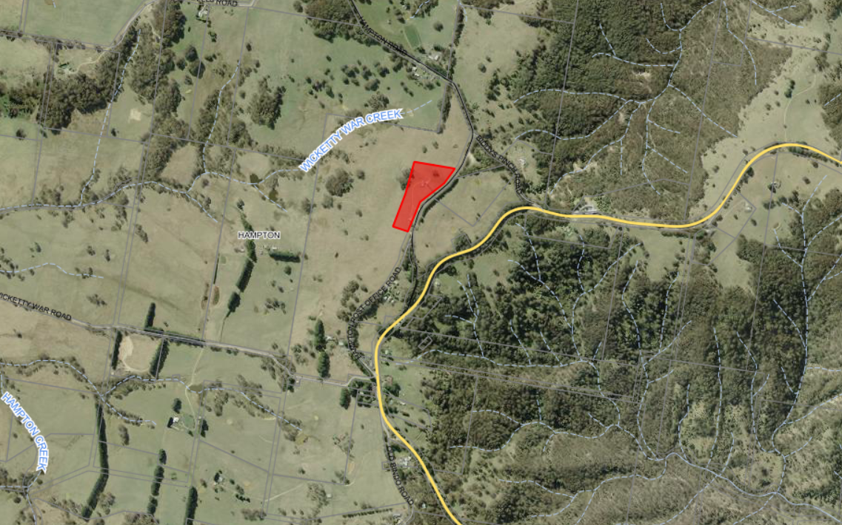 Figure 1: Aerial Image of the development site,2025
Hampton Village, including school
Jenolan Caves Road
Jenolan Caves Road
Local Heritage Listed Item-Hampton Road House & Cottage
Local Heritage Listed Item-The Stone Cottage
Local Heritage Listed Item-Cottage
Hampton Road
Sydney via Lowther & Good Forest
Lithgow

Oberon Via Tarana
Oberon
Hampton Halfway Hotel/Motel
Development
Site

The topography of the development site is relatively flat with a slight fall to the west. The site is surrounded by hilly mountain ranges. valleys and ridges.

The property and that section of Hampton Road is located on a higher elevation than surrounding properties and overlooks the escarpment in all directions.

The site is predominantly cleared with small patches of vegetation. The proposed location for the new towers is clear of existing vegetation, other than grasslands.

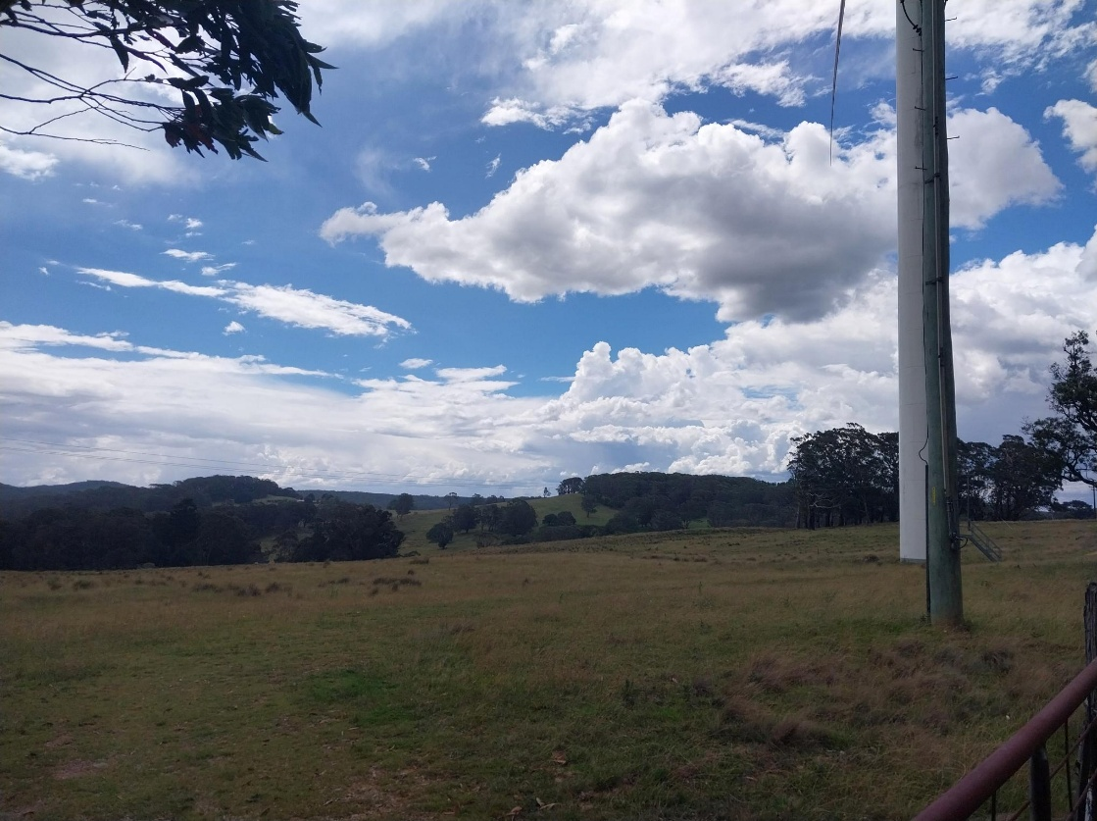
Figure 2: Photo of the property from Hampton Road, 18 February 2026

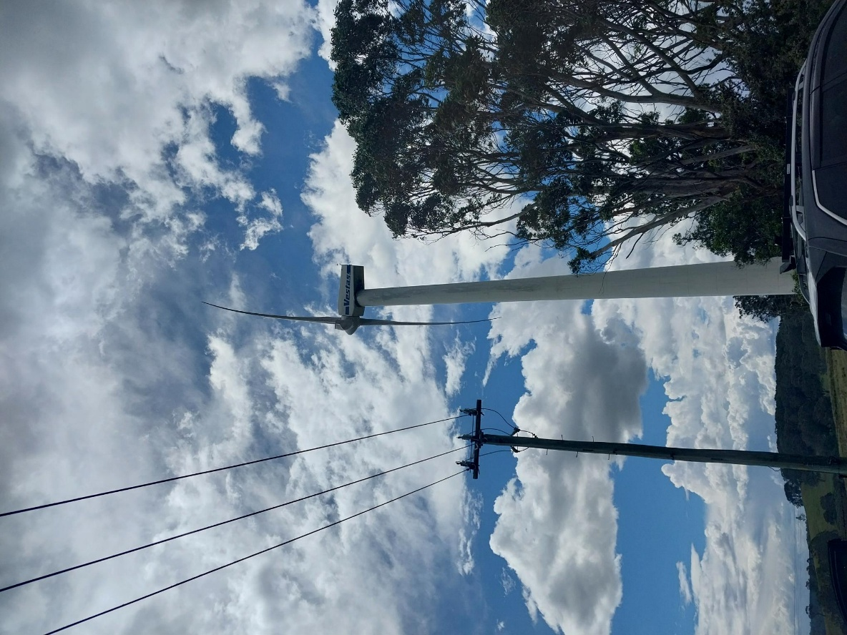
Figure 3: Photo of one of the current wind turbines on the property, from the current access entrance, 18 February 2026

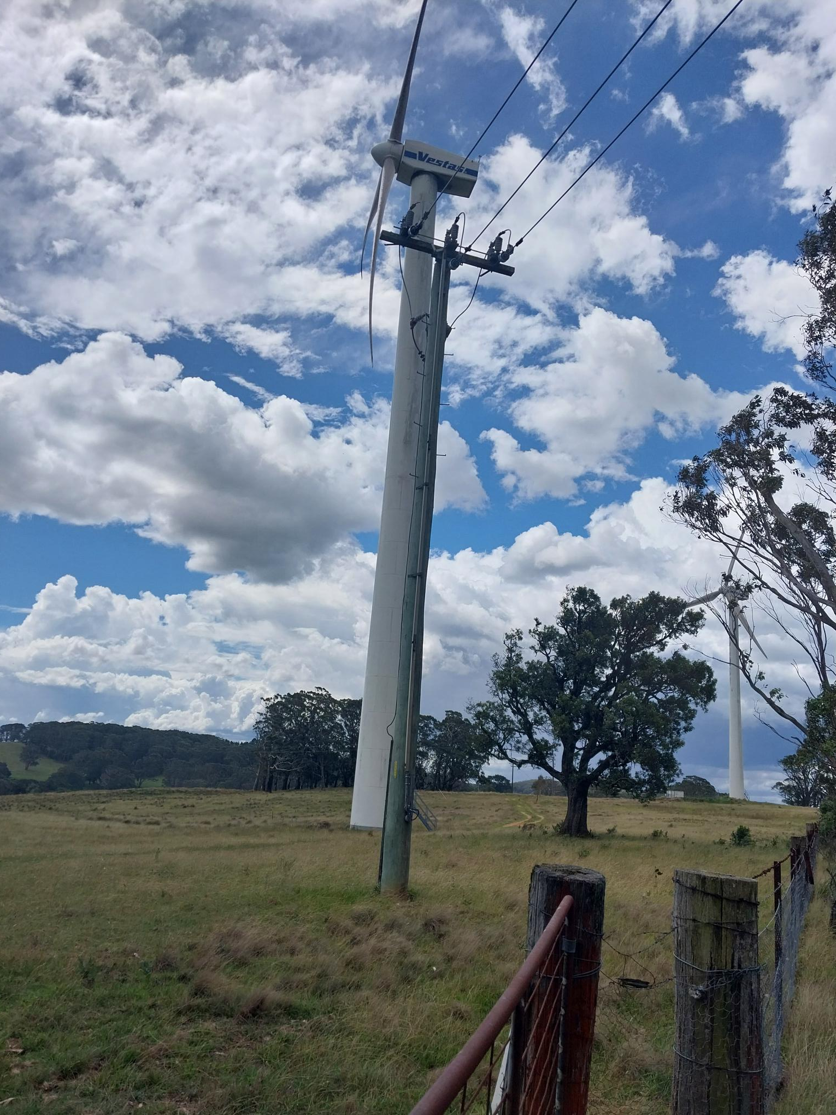
Figure 4: Photo of one of the current wind turbines on the property, from the current access entrance, 18 February 2026

- THE PROPOSAL AND BACKGROUND

  - The Proposal
The application is seeking consent for the decommissioning and removal of the existing two wind turbines and construction and assembly of two new wind turbines.

By way of background, on 18 September 2000, Consent was issued for the construction of a wind farm involving two turbines (660kW) on the property (DA96/01). These turbines are now near the end of their economic life and needs replacing and upgrading.

The new turbines are proposed to have the following specifications:
- Height (total)- 120m
- Rotor Diameter- 80m
- Blade Length- 39m
- No. of Blades- 3 each
- Hub Height- 80m
- Capacity of 2 megawatts

The turbines are proposed to be larger than the existing turbines and would extend the economic life and power output.

It is expected that the new turbines may have a future lifespan of 30-40 years.

The comparison between the existing and proposed turbines are shown in the table below:

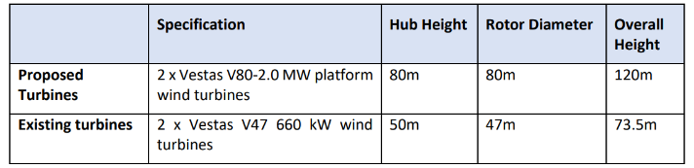

As such the proposed turbines would be approximately 1.6 times the height of the existing ones.

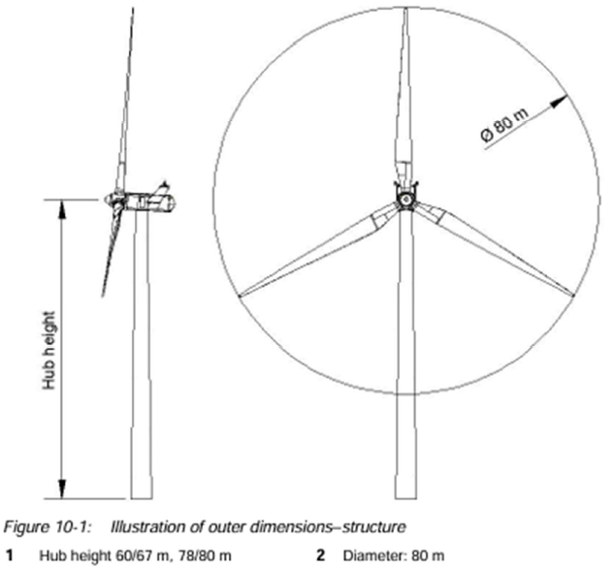
Figure 5: Wind turbine Elevations

The location of the proposed turbines would be closer to the north and west boundary of the allotment. This would have the blades overhanging over the adjoining property of Lot 2 DP1031694. The owner of Lot 2 has granted consent to the lodgement of the development and acknowledges the overhang of the blades and near boundary impacts.

The reuse of the existing mounting systems is not found to be feasible due to structural purposes; therefore, both turbines would be mounted on new systems. The existing internal track would further be extended to the new pad sites.

All switchgear and transformers are to be placed inside the towers, with electrical and communication cabling to be below ground between the wind turbines and the network.

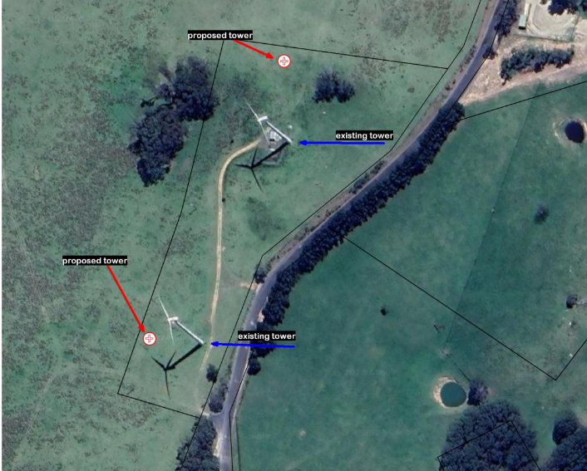
Figure 6: Site Plan

Demolition
A Demolition Program would be undertaken for the decommissioning of the existing turbines by utilising a 600t crane and 6 x 19m trucks. The site would be remediated and topsoiled. The total decommissioning is expected to take approximately 14 days.

It is intended that the existing turbines would be dismantled and refurbished for use on another site within Australia, or alternatively, if not feasible, be recycled (metal components) and disposed.

Construction
The construction of the new turbines involves:
- Existing hardstands and roads to be upgraded with additional road base,
- Additional construction pads to be established,
- Excavation of new rock footings and disposal of material by backfilling former anchor/footing sites,
- Installation of rock anchor base plate and drilling,
- Mobilisation and installation of towers,
- Minor looping of overhanging vegetation (traffic hazard) within the road reserve for the towers to be transported to the site.

The total construction is expected to take approximately 4 days, utilising 600t crane, 6 light vehicles and 2 heavy vehicles.

Transportation to the site
A report was submitted with the application detailing a feasible haulage route for turbine components. The route involves starting at the Newcastle port through Dunedoo, Mudgee, Bathurst, Oberon and then via Duckmaloi Road, Jenolan Caves Road onto Hampton Road.

The report identifies some vegetation on Hampton Road to be lopped on one of the corners on Hampton Road due to traffic hazard.

  - Background

The development application was lodged on 3 October 2025. A chronology of the development application since lodgement is outlined below including the Panel’s involvement (briefings, deferrals etc) with the application:
Table 2: Chronology of the DA
Date | Event
3 October 2025 | DA lodged
13 October 2025 | Application was notified in the Planning Portal to the Western Regional Planning Panel and to some external Government Authorities.
15 October 2025 | Endeavour Energy response received.
15 October 2025 | Additional documentation submitted by the Applicant.
17 October 2025 | Exhibition of the application to surrounding properties and to External Government Authorities
23 October 2025 | Additional information submitted by the Applicant.
27 October 2025 | WaterNSW Determination Received.
6 November 2025 | Letter received from the applicant requesting extension of time for the public notification period.
28 November 2025 | Additional Information request from Transport for NSW.
16 December 2026 | Council requested additional Information from the applicant relating to:  - Noise,  - Visual Assessment,  - Purpose,  - Traffic,  - Roadside Vegetation Management,  - Heritage,  - Decommissioning,  - Compliance with the Lithgow Council’s Development Control Plan 2021,  - Compliance with the Wind Energy Guidelines,  - Biodiversity,  - Voluntary Planning Contribution,  - Electricity Regulation,  - Transport for NSW Requirements,  - Mid Western Regional Council Concerns,  - Oberon Council Concerns,  - Community Concerns
22 December 2025 | WaterNSW requested additional information after further review of the application.
13 January 2026 | Applicant advised that the additional information is being worked on and would be submitted shortly.
18 February 2026 | Site meeting was undertaken with the Panel representatives and Council’s Assessment Officers.
7 August 2026 | Council request the applicant to provide the outstanding information as per Council’s previous RFI.
1 September 2026 | Council emailed and attempted to contact the applicant for an update to the development application and the recommendation to withdraw the application.

  - Site History

DA89/99- Butt Sectioned Guyed 45m High Tower CSIRO Wind Monitoring- Approved by Council 29 March 1999

DA362/00- Deferred Commencement Consent: Electricity Wind Turbine System (Wind Farm x2 turbines)- Approved by Council 18 September 2000

DA96/01- Electricity Wind Turbine System (Wind Farm x2 turbines)- Approved by Council 18 September 2000

DA79/01- Subdivision (Wind Park Site) one lot into two- Approved by Council 21 March 2001
DACC096/09- Approved Earthworks/Shipping Containers and Transformer approved by Council 26 June 2009

The development involved the placement of temporary (maximum of 18 months), 6 x 20 foot containers to house batteries. In addition to the containers, 2 small transformers were placed on the property.

DA016/11- Approved the continued use of the shipping containers and transformers for an additional 2 years, approved by Council, 24 May 2011.

- STATUTORY CONSIDERATIONS

  - Relevant Commonwealth Legislation

Environment Protection and Biodiversity Conservation Act 1999 (Cth) (EPBC Act) | The EPBC Act refers to the living things (including plants and animals), habitats and places that need protecting as 'matters of national environmental significance'. These relate to Commonwealth land, Commonwealth heritage places overseas or Australian Government Agency.  Insufficient information has been provided to date to determine whether the EPBC Act requires consideration.

  - Relevant State (NSW) Legislation

In addition to the Environmental Planning and Assessment Act 1979, the following NSW legislation has been considered. Where relevant, further detailed assessment of the proposed development against the various Acts have been included throughout this report.

Biodiversity Conservation Act 2016  (BCAct) | The proposal has been assessed in relation to clearing of native vegetation and the Biodiversity Offset Scheme threshold under the provisions of this Act. The works proposed do not require any further biodiversity assessment under this scheme. A desktop assessment of threatened species using the BioNet Atlas has been undertaken and identified the Verreaux’s Frog and Spotted Grass Frog, Silvereye, to be located within the vicinity of the development.  It is estimated that an area of 4,000m² will be impacted during construction.  The base of the new towers contain 8m diameter each. It is proposed that the site with the existing towers to be removed will be rehabilitated.  Minor lopping of overhead vegetation on the road reserve may be required to avoid traffic hazard for access to the site.  To date limited information in relation to the act has been submitted for Council assessment.
National Park and Wildlife Act 1974 (NP&WAct) | There are no recorded heritage sites identified within the development locality under the Aboriginal Heritage Information Management System (AHIMS).  The development is located on a ridge, where groundcover is sparse. The property contains no history of Aboriginal sites being present nor does it contain any significant topographic features. On the basis of the existing development and the absence of any formations where site might usually be expected, the development would have no impact on Aboriginal heritage relics or sites.  Therefore, the development complies with the National Park and Wildlife Act 1974.
Roads Act 1993 (Roads Act) | A traffic route study was undertaken and submitted with the application. The study indicates that the development proposes to transport the new turbines from the port at Newcastle through Dunedoo, Mudgee, Bathurst, Oberon and then via Buckmaloi Road and Jenolan Caves Road onto Hampton Road.  The application as such proposes to utilise a mixture of local and state road networks.  The report concluded that the route would require a number of upgrades before it could be deemed suitable for transporting the turbines. This includes bridges, overhead structures/utilities (i.e. rail signals), vegetation and road pavements.  Given the size of the turbines and the potential impacts resulting from dilapidation, the lopping of vegetation along the road reserve and safety on the roads, the application was referred to Transport for NSW for assessment.  Transport for NSW requires additional information for assessment of the application. To date this information has not been received.
Contaminated Land Management Act 1997 (CLMAct) | The site has no known history of contamination.  There is no impact of runoff from the current wind turbines. Lubricating fluids are known to be fully contained within the turbine elements.  No threat to groundwater is anticipated, as rock is very close to the surface, and no significant groundwater sources affect the site.  It is intended that the existing turbines would be dismantled and refurbished for use on another site within Australia, or alternatively, if not feasible, be recycled (metal components) and disposed of at a licenced waste facility.  As such, Council is satisfied that contamination from current and proposed uses would have minimal contamination impacts.
Protection of the Environment Operations Act 1997 (POEOAct) | The proposal does not trigger the requirement for an Environmental Protection Licence under the POEO Act.  A noise and vibration assessment was undertaken and submitted with the application and found that the development would comply with the Environment Protection Authority Guidelines- NSW Noise Policy for Industry 2017, Noise Construction Guidelines and DECC (2012) NSW Wind Farm Guidelines
Crown Land Management Act 2016 (CLMAct) | The development does not involve the use of Crown Land.
Coal Mine Subsidence Compensation Act 2017 | The development is not located within the Subsidence district area.
Water Management Act 2000 (WMAct) | The carrying out of development within 40m of watercourse requires a “controlled activity approval” under Section 91 of the Water Management Act 2000 (WM Act 2000) from the Department of Climate Change, Energy, Environment and Water- Water.  There are no water courses in proximity of the development site.  The development was referred to Water NSW who requires additional information for assessment.
Fisheries Management Act 1994 | The carrying out of development that constructs or alters a dam, floodgate, causeway or weir, or otherwise creases an obstruction across a creek, requires a permit under Section 219 of the Fisheries Management Act 1994.  The development will not impact on any fisheries areas or waterways. Therefore, no further consideration is required under the Act.
Biosecurity Act 2015 (Biosecurity Act) | The development is located within an urban area and therefore does not trigger the Biosecurity Act.
Conveyancing Act 1919 | DP1031694- shows a restriction on title that the allotment shall not erect or suffer to permit any dwelling and that Lot 1 shall be consolidated into Lot 2 DP1031694 in the event of power generation ceasing on Lot 1.  This requirement would remain on the title.
Rural Fires Act 1997 | The application is not defined as being a special fire protection purpose under Section 100B, under Planning for Bushfire Purposes.  Grassland management is required around the turbines and would be conditioned on the consent should the application be approved.  As such, the development complies with the Rural Fires Act 1997.

  - Part 4 Environmental Planning and Assessment Act, 1979

Matters for Consideration – General (Section 4.15)

When determining a development application, the consent authority must take into consideration the matters outlined in Section 4.15(1) of the Environmental Planning and Assessment Act 1979 (‘EP&A Act’). These matters as are of relevance to the development application include the following:

- the provisions of any environmental planning instrument, proposed instrument, development control plan, planning agreement and the regulations
(i) any environmental planning instrument, and
(ii) any proposed instrument that is or has been the subject of public consultation under this Act and that has been notified to the consent authority (unless the Planning Secretary has notified the consent authority that the making of the proposed instrument has been deferred indefinitely or has not been approved), and
(iii) any development control plan, and
(iiia) any planning agreement that has been entered into under section 7.4, or any draft planning agreement that a developer has offered to enter into under section 7.4, and
(iv) the regulations (to the extent that they prescribe matters for the purposes of this paragraph),
that apply to the land to which the development application relates,
- the likely impacts of that development, including environmental impacts on both the natural and built environments, and social and economic impacts in the locality,
- the suitability of the site for the development,
- any submissions made in accordance with this Act or the regulations,
- the public interest.

These matters are further considered below.

  - Environmental Planning Instruments, proposed instrument, development control plan, planning agreement and the regulations

The relevant environmental planning instruments, proposed instruments, development control plans, planning agreements and the matters for consideration under the Regulation are considered below.

- Section 4.15(1)(a)(i) - Provisions of Environmental Planning Instruments

The following Environmental Planning Instruments are relevant to this application:

- State Environmental Planning Policy (Biodiversity & Conservation) 2021,
- State Environmental Planning Policy (Planning Systems) 2021,
- State Environmental Planning Policy (Resilience & Hazards) 2021,
- State Environmental Planning Policy (Transport and Infrastructure) 2021,
- Lithgow Local Environmental Plan 2014 (LLEP2014).

A summary of the key matters for consideration arising from these State Environmental Planning Policies are outlined in Table 3 and considered in more detail below.

Table 3: Summary of Applicable Environmental Planning Instruments

EPI | Matters for Consideration | Comply (Y/N)
State Environmental Planning Policy (Biodiversity & Conservation) 2021 | Chapter 3: Koala Habitat Protection 2020  This policy aims to encourage the conservation and management of areas of natural vegetation that provide habitat for koalas to support a permanent free-living population over their present range and reverse the current trend of koala population decline. The SEPP replaces the previous State Environmental Planning Policy No 44 - Koala Habitat Protection.  Chapter 3 applies to land of more than 1 hectare in area.  Chapter 4: Koala Habitat Protection 2021  Section 4.8 requires that the application must be consistent with the approved koala plan of management that applies to the site.  The site is within the Central and Southern Tablelands Koala Management Area. At this stage Lithgow has no Koala Management Plan endorsed.  Given that the proposed development does not require the removal of trees, it is considered koala habits will not be impacted or impede movement between koala habitats. Because of this, the proposal is categorised as Tier 1 development having (low impact) under the Koala Habitat Protection Guidelines and development consent can be granted in accordance with the clause above.  Chapter 6: Water Catchments  The development site is located within the Sydney Drinking Water Catchment (SDWC).  The development was referred to the Water NSW who requires additional information for assessment. To date the outstanding information has not been received. | No
State Environmental Planning Policy (Planning Systems) 2021 | Chapter 2: State and Regional Development  Section 2.19(1) declares the proposal to be regionally significant development under Clause 5 of Schedule 6.  Clause 5 Private infrastructure and community facilities over $5 million  (a) air transport facilities, electricity generating works, port facilities, rail infrastructure facilities, road infrastructure facilities, sewerage systems, telecommunications facilities, waste or resource management facilities, water supply systems, or wharf or boating facilities, | Yes
SEPP (Resilience & Hazards) | Contamination  Council is satisfied that the land is not contaminated given the past agricultural grazing uses and current wind turbines.  Remediation  The existing turbines would be fully dismantled and removed from the site along with any infrastructure that becomes redundant consequent upon the decommissioning of the existing turbines.  Council requested a detailed decommission plan to be submitted. To date this information has not been received. | No
State Environmental Planning Policy (Transport and Infrastructure) 2021 | Chapter 2: Infrastructure  - Subdivision 2 Development likely to affect an electricity transmission or distribution network  - Section 2.48(2) (Determination of development applications—other development) – electricity transmission - the proposal satisfies this section, subject to recommended conditions. | Yes
Lithgow Local Environment Plan 2014 (LLEP2014) | - Clause 2.3 – Zone Objectives and Land Use Table  - Clause 7.1 – Consideration of earthworks  - Clause 7.3 – Stormwater management  - Clause 7.8 - Development within a designated buffer area | No
Lithgow Development Control Plan 2021 (LDCP2021) | - Chapter 2 – Site Requirements  - Chapter 3 – Environment and Hazards  - Chapter 8 – Rural & Other Land Uses | No
Wind Energy Guideline November 2024, Department of Planning, Housing and Infrastructure | - Chapter 2- Planning Framework  - Chapter 5- Assessment Issues and Requirements  - Chapter 6- Other Assessment Issues | No

Further considerations of the relevant SEPPs are outlined in more detail below:

State Environmental Planning Policy (Biodiversity and Conservation) 2021

Chapter 6: Water Catchments
Chapter Six – Water Catchments of the B&C SEPP applies to the development pursuant to Clause 6.1, as the development is located within the Sydney Drinking Water Catchment (SDWC).

Part 6.2 of Chapter Six lists several controls that development within a regulated catchment must consider when determining to grant consent. As such, the development was referred to Water NSW. Water NSW provided that the following comments:
‘The subject property, which has been inspected by Water NSW, is located within the Warragamba catchment which forms part of Sydney's water supply.

Water NSW notes that there will be minor increase in the impervious area at the site due primarily to the construction of the footings (less than 250 square metres).

WaterNSW requires additional information to be submitted for an adequate assessment of the application.

State Environmental Planning Policy (Planning Systems) 2021 (‘Planning Systems SEPP’)

Chapter 2: State and Regional Development

The proposal is ‘regionally significant development’ pursuant to Section 2.19(1) and Clause 5 of Schedule 6 of the Planning Systems SEPP because it consists of electricity generating works with a capital investment value exceeding $5 million. Accordingly, the Western Regional Planning Panel is the consent authority for the application.

State Environmental Planning Policy (Transport and Infrastructure) 2021

Chapter 2: Infrastructure
Section 2.48(2) (Determination of development applications—other development) – electricity transmission - the proposal satisfies this section, subject to recommended conditions.

The development was referred to Endeavour Energy who has no objection to the application subject to conditions placed on the consent.

Lithgow Local Environmental Plan 2014

The relevant local environmental plan applying to the site is the Lithgow Local Environmental Plan 2014 (‘the LEP’). The aims of the LEP include:

(aa) to protect and promote the use and development of land for arts and cultural activity, including music and other performance arts,

(a) to encourage sustainable and planned development that complements the unique character and amenity of Lithgow and enhances its towns, villages and rural areas,

(b) to provide for a range of development opportunities that contribute to the social, economic and environmental resources of Lithgow in a way that allows the needs of present and future generations to be met by implementing the principles of ecologically sustainable development,

(c) to manage, facilitate and encourage sustainable growth and development that—

(i) promotes the efficient and effective delivery of utilities, infrastructure and service and minimises long-term costs to government, authorities and the community, and

(ii) protects, enhances and conserves mineral and extractive resources lands, forests and agricultural lands and the contributions they make to the local, regional and State economy, and
(iii) allows for the orderly growth of land uses while minimising conflict between land uses in a zone and land uses in adjoining zones, and

(iv) encourages a range of housing choices in planned urban and rural locations to meet population growth and the diverse needs of the community, and

(v) preserves and protects land that has been identified for future long-term urban development from inappropriate fragmentation and development, and

(vi) protects and enhances environmentally sensitive areas, ecological systems, areas of high scenic, recreational, landscape or conservation value and areas that have the potential to contribute to improved environmental outcomes, and

(vii) protects and enhances places and items of environmental, archaeological, cultural or heritage significance, including Aboriginal relics and places, and

(viii) avoids or minimises the impact of development on drinking and environmental water catchments to protect and enhance water availability and safety for human consumption and the maintenance of environmental and recreational values, and

(ix) strengthens and promotes employment land opportunities and appropriate tourism development and growth, and

(x) creates resilience to natural hazards through local land use planning.

Council has received insufficient information from the applicant to determine whether the application complies with the aims of the LEP.

Zoning and Permissibility
The proposal is located within the RU1 Primary Production land use zone under Clause 2.3 of the Lithgow Local Environmental Plan 2014 (LLEP2014).

The development is defined as being “electricity generating works” under the Lithgow LEP 2014.

Definition
electricity generating works means a building or place used for the purpose of—
(a) making or generating electricity, or
(b) electricity storage.

Permissibility
The development is permissible in the zone under Clause 2.36, Part 2.3 Division 4, Electricity generating works or solar energy systems, of The NSW State Environmental Planning Policy (Transport and Infrastructure) 2021.

Figure 7 below shows the LLEP2014 zoning map of the property:

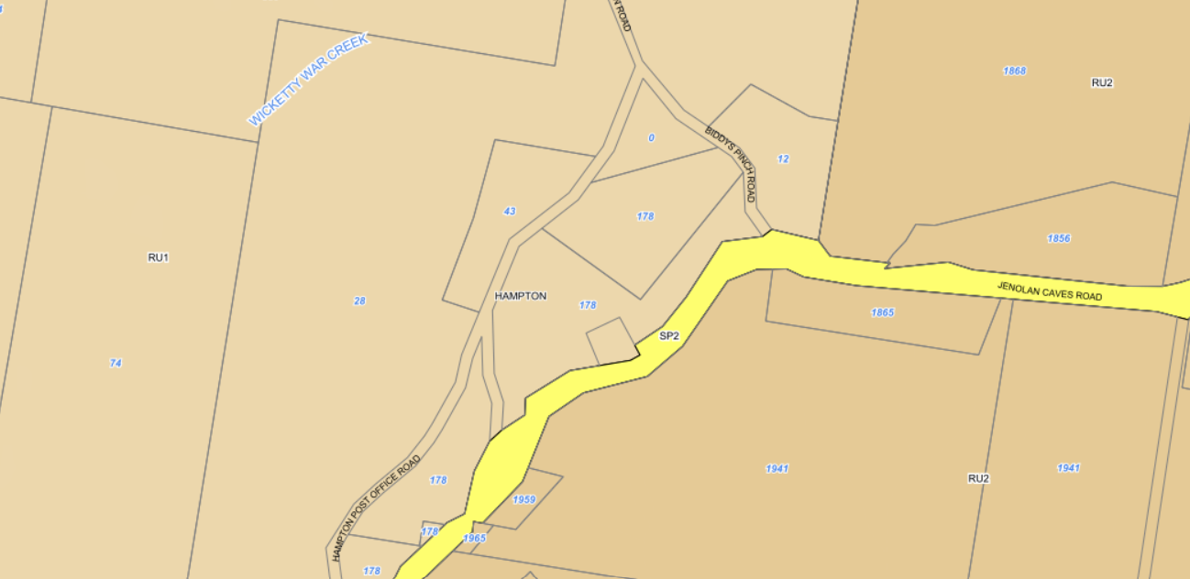
Figure 7: Zoning map (LLEP2014)

The zone objectives include the following (pursuant to the Land Use Table in Clause 2.3):

Zone | Objectives of zone
RU1 Primary Production | • To encourage sustainable primary industry production by maintaining and enhancing the natural resource base.  • To encourage diversity in primary industry enterprises and systems appropriate for the area.  • To minimise the fragmentation and alienation of resource lands.  • To minimise conflict between land uses within this zone and land uses within adjoining zones.  • To minimise the environmental and visual impact of development on the rural landscape.  • To provide for recreational and tourist development and activities of an appropriate type and scale that do not detract from the economic resource, environmental or conservation value of the land.  • To maintain or improve the water quality of receiving water catchments.

Council has received insufficient information from the applicant to determine whether the application complies with the zone objectives.

General Controls and Development Standards (Part 7)

The LEP 2014 contains controls relating to development standards, miscellaneous provisions and local provisions. The controls relevant to the proposal are considered below.

Control | Requirement | Proposal | Comply
Earthworks (Cl 7.1) | In deciding whether to grant development consent for earthworks (or for development involving ancillary earthworks), the consent authority must consider the following matters—  - the likely disruption of, or any detrimental effect on, drainage patterns and soil stability in the locality of the development,  - the effect of the development on the likely future use or redevelopment of the land,  - the quality of the fill or the soil to be excavated, or both,  - the effect of the development on the existing and likely amenity of adjoining properties,  - the source of any fill material and the destination of any excavated material,  - the likelihood of disturbing relics,  - the proximity to, and potential for adverse impacts on, any waterway, drinking water catchment or environmentally sensitive area,  - any appropriate measures proposed to avoid, minimise or mitigate the impacts of the development,  - the proximity to, and potential for adverse impacts on, any heritage item, archaeological site or heritage conservation area. | The development includes earthworks works for the construction of the new turbines and decommission of the existing turbines.  Council has received insufficient information from the applicant to determine whether the application complies with Clause 7.1. | No
Stormwater Management (Cl 7.3) | In deciding whether to grant development consent for stormwater management, the consent authority must consider the following matters—  - is designed to maximise the use of water permeable surfaces on the land having regard to the soil characteristics affecting on-site infiltration of water, and  - includes, if practicable, on-site stormwater retention for use as an alternative supply to mains water, groundwater or river water, and  - avoids any significant adverse impacts of stormwater runoff on adjoining properties, native bushland and receiving waters, or if that impact cannot be reasonably avoided, minimises and mitigates the impact. | The proposed development includes minimal construction of permeable surfaces. As such it is considered that the development will not interrupt or significantly alter the natural flow of water through the existing drainage line.  Council has received insufficient information from the applicant to determine whether the application complies with Clause 7.3. | No
Development within a designated buffer area (Cl 7.8) | (3) Before granting development consent for development on land to which this clause applies, the consent authority must consider the following—  (a) the impact that any noise and other emissions associated with existing land uses would have on the development,  (b) any measures incorporated into the development that would limit the impact of noise, odour and other emissions associated with the existing land use,  (c) any opportunities to relocate the development outside the land to which this clause applies,  (d) whether the proposed development would adversely affect the operational environment of any existing development on the land to which this clause applies. | The site is located within a designated buffer area due to proximity to Councils Waste facility on land known as Lot 1 DP 543627.  The noise impacts from the development is not proposed to impact Council’s Waste Facility or the operational use of the land.  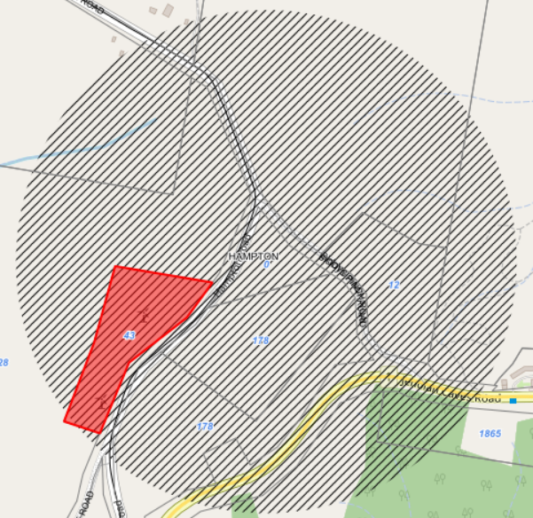 | Yes

- Section 4.15 (1)(a)(ii) - Provisions of any Proposed Instruments

Nil.

- Section 4.15(1)(a)(iii) - Provisions of any Development Control Plan

Section 4.15(1)(a)(iii) of the EP&A Act requires Council to consider the provisions of any development control plans.

The development has been assessed having regard to the relevant desired outcomes and prescriptive requirements within the Lithgow Development Control Plan 2021 (LDCP2021).

Lithgow Development Control Plan 2021

LDCP2021  Clause | Requirement | Assessment Comments | Compliance
Chapter 2 – Site Requirements | Site Analysis demonstrates that the design of the proposed development has responded to an analysis of the site and its relevant context. | Large rural residential allotments (scattered dwellings and ancillary uses) adjoins the property with the Hampton Village (within 1km) located to the south. The village contains numerous residential uses, Anglican Church, Hampton Public School and local heritage items such as The Stone Cottage, Hampton Road House, cottages. The Hampton Halfway Hotel/Motel is located to the east of the site. This is also a local heritage listed item.  Council has received insufficient information from the applicant to determine whether the application complies with the Lithgow DCP. | No
2.2 Site Analysis, Local Character and Context |  |  | No
2.2.2 Site Analysis & Development Response |  |  | No
2.2.3 Local Character & Context | Character: All applications demonstrate that the proposed development has considered the local existing and desired future character of the area and that the proposed development is consistent with and/or integrates with this character. | Council has received insufficient information from the applicant to determine whether the application complies with the Lithgow DCP. | No
2.2.4 Visually Prominent Sites | Development on a visually prominent site, particularly in rural and/or environmental zones or in heritage conservation areas, is sited and designed to minimise visual and environmental impact. | Council has received insufficient information from the applicant to determine whether the application complies with the Lithgow DCP. | No
2.3 Slope Response, Earthworks & Retaining Walls | - Description: All development that involves any significant earthworks provides a plan and/or description of the location, extent and depth of earthworks that forms part of the application.  - LLEP2014: All development that involves any significant earthworks addresses Clause 7.1 - Earthworks of LLEP2014.  - Design: Developments on sloping sites are sited, designed and use construction techniques that respond to the topographical (slope) & hydrological (water) features of the site. Alternatives to slab on ground construction should be utilised where, due to gradient and characteristics of the site, such form of construction is inappropriate.  - Impact: Depending on the likelihood and significance of impact of any proposed earthworks on the matters raised in the objectives of this Section, Council may require justification for the need for those earthworks AND additional plans/reports/certification to demonstrate that the impacts can be avoided, mitigated or minimised (for examples, see table below).  - Drainage: Disturbance to natural drainage patterns is minimised and addresses Section 2.5 Stormwater Management of this DCP.  - Batters:  - Cut and fill batters do not exceed a slope of 1V:2H (vertical to horizontal) depending on soil classification or Council is satisfied of sufficient site stability by a Geo-technical and/or Structural Report; and  - All batters are to be provided with both short and long-term stabilisation to prevent soil erosion and do not extend onto public or adjoining land without permission. | The development includes earthworks works for the construction of the new turbines and decommission of the existing turbines.  Council has received insufficient information from the applicant to determine whether the application complies with the Lithgow DCP. | No
2.3.1 Earthworks  2.3.2 Retaining Walls |  |  | No
2.4 Stormwater Management | - Application: Development applications (in accordance with Council's DA Guide) may need to provide a Stormwater Drainage (Concept) Plan (SDCP) and/or Soil and Water Management Plan (SWMP) addressing stormwater management on the Site.  - Guidelines: All Stormwater drainage is designed to comply with Council's Engineering Guidelines – Section 3 – Stormwater Drainage.  - Drinking Catchment: Unless there is 'no identifiable potential impact', all development within the Sydney Drinking Water Catchment demonstrates a neutral or beneficial effect upon water quality in accordance with the requirements of SEPP (Sydney Water Drinking Catchment) 2011. | Council has received insufficient information from the applicant to determine whether the application complies with the Lithgow DCP. | No
2.5 Vehicle Access and Parking | All development is e.g., designed to be consistent with (as amended):  - Council’s Guidelines for Civil Engineering Design and Construction for Development (2012) ('Engineering Guidelines').  - RTA (now Transport for NSW) (2002) Guide to Traffic Generating Developments; and  - Relevant Australian Standards including but not limited to (as amended):  - AS2890 – Parking facilities including:  - AS2890.1 (2004) – Off-street car parking.  - AS2890.2 (2018) – Off-street commercial vehicle facilities.  iii. AS2890.3 (2015) – Bicycle parking facilities.  iv. AS2890.6 (2009) – Off-street parking for people with disabilities  - AS1428 – Design for Access and Mobility.  - Relevant Austroads Guidelines; and  - Relevant Council Policies. | Council has received insufficient information from the applicant to determine whether the application complies with the Lithgow DCP. | No
2.5.4 Parking Location, Design & Circulation | 1) Parking Location,  2) Parking Design,  3) Accessible Parking,  4) Safety,  5) Sealed Vehicle Areas,  6) Stormwater,  7) Vehicle Sizes,  8) Operating Hours,  9) Basement Parking,  10) Stacked Parking,  11) Circulation,  12) Parking Navigation,  13) Lighting,  14) Visual Impact | Council has received insufficient information from the applicant to determine whether the application complies with the Lithgow DCP. | No
2.5.5 On-Site Parking Numbers | The DCP does not specify the number of parking spaces required for the development. | NA | NA
2.5.7 Bicycle Parking | The DCP does not specify the number of bicycle parking spaces required for a Wind Farm. | NA | NA
2.6 Pedestrian Access, Mobility & Safety | Accessibility  1) Access to Premises Standards,  2) National Construction Code,  3) Australian Standards. | NA | NA
2.7 Designing for Crime Prevention | Crime Risk Assessment  Objective 1  To ensure that new larger developments and subdivisions (see table below), and/or significant alterations and additions to existing larger developments (see table below) has:  - Considered how it may improve safety and reduce the facilitation of criminal activity.  - Demonstrated how the design has responded to the four (4) main principles of crime prevention including: territorial re-enforcement, surveillance, access control and space/activity management to create the perception or reality of reduced opportunity for crime or inappropriate behaviour.  - Provided appropriate lighting that enhances safety and security whilst minimising impacts from light-spill or inappropriate lighting on neighbouring properties. | Given the type of development being wind towers, crime prevention is not warranted. Fencing is existing around the site. | Yes
2.8 Utilities, Easements & Infrastructure | 2.8.1 – Connections Utilities  2.8.2 – Building Near Utilities/Easements/Drainage Lines  2.8.6 – Water Supply | The development site is not serviced by water or sewer infrastructure, and is not required to be connected.  The new turbine sites will connect to the electricity grid, as presently connected, with cabling upgrading as needed from the two new platforms.  The development will not be built over any easements with adequate setbacks. | Yes
2.9 Solid Waste Management | Waste Storage and Collection – Larger Developments | Council has received insufficient information from the applicant to determine whether the application complies with the Lithgow DCP. | No
Chapter 3 – Natural Environment and Hazards
3.2 Bush Fire Prone Land | Where a proposed development is on land identified as bush fire prone on the Bush Fire Prone Land Map, the design and management of any proposed development on that bush fire prone land complies with the following:  - Rural Fire Act 1997 (NSW) & the associated Rural Fires Regulation 2013 (as amended); and  - NSW Rural Fire Service (2019) Planning for Bush Fire Protection (Bush Fire Guidelines).  - Any development application involving the erection of a dwelling house or alterations and additions to an existing dwelling house on bush fire prone land addresses the requirements contained in:  - The NSW Rural Fire Service (RFS) publication titled “Building in Bush Fire Prone Areas Single Dwelling Applicants Kit” found on the RFS website (www.rfs.nsw.gov.au); and  - Australian Standard AS3959 – 2009 Construction of Buildings in Bush Fire Prone Areas (for any Construction Certificate application). A suitably qualified person may need to provide a schedule of compliance with the applicable construction standards. This schedule will form part of the approval documentation and the applicant will be required to comply with it during the course of construction; and  - National Construction Code (NCC) may specify additional controls for the construction of buildings on bushfire-prone lands. | The subject property is noted as being Bushfire Prone Land. The proposed facility will not increase the possibility of a bushfire on the subject property, nor will it exacerbate any possible bushfire activity. As the development is not habitable or defined as a special fire protection development, the development is considered to be exempt for RFS requirements. | Yes
3.3 Vegetation Management and Biodiversity | 1) To protect and enhance significant native vegetation, ecological corridors/processes, biodiversity and native flora/fauna (particularly threatened species or ecological communities) in the Lithgow LGA for the benefit of both the natural environment and human sustainability.  2) To encourage retention (where possible) of native and other vegetation that can improve environmental outcomes, provide amenity and character, act as a buffer to development, and improve the sustainability of development. | Council has received insufficient information from the applicant to determine whether the application complies with the Lithgow DCP. | No.
3.3.1 Vegetation Clearing for Development Requiring Consent |  |  | No.
3.3.2 Threatened/  Endangered Species/ Ecological Communities |  |  | No.
3.4 Land and Soils | In order to satisfy the requirements of Clause 7.7 - Sensitive Lands, particularly subclause (4) that:  - The development is designed, sited and will be managed to avoid significant adverse environmental impact, or  - If that impact cannot be avoided—the development is designed, sited and will be managed to minimise that impact, or  - If that impact cannot be minimised—the development will be managed to mitigate that impact. | Council has received insufficient information from the applicant to determine whether the application complies with the Lithgow DCP. | No
3.4.1 Contaminated Land |  |  | No
3.4.3 Erosion & Sedimentation |  |  | No
Chapter 8 – Rural and Other Land Uses
8.8 Solar Energy & Wind Farms | Road Upgrades  Much of Council’s road network is generally not capable of sustaining the increase in large scale construction traffic and may require substantial upgrading to accommodate construction vehicles. Appropriate bonds will be required to ensure any road damage is repaired to Council’s satisfaction. Such bonds are payable prior to commencement of any works on the site. Road sealing shall be required where appropriate on unsealed public roads utilised by the proponent.  Consultation with State Government Authorities  Proponents are advised to consult with public authorities that may have a role in assessing the Development Application. Council may also consult with those relevant public authorities during the application process.  Developer Contributions  Council will seek to negotiate voluntary planning agreements for major solar energy farm developments in accordance with Section 7.4 of the Environmental Planning and Assessment Act 1979. However, this does not exclude application of Section 7.11 or 7.12 Developer Contributions in accordance with the relevant Contributions Plan in force at the time of determination. | Council has received insufficient information from the applicant to determine whether the application complies with the Lithgow DCP. | No
8.8 Solar Energy & Wind Farms | Objective(s)  O1. To minimise potential land use conflicts.  O2. To ensure that there is no unreasonable interference with the comfort or use of adjoining land.  O3. To ensure that impacts on agricultural land, businesses and tourism are appropriately considered.  O4. To ensure road access, visual impacts, noise, health, waste, construction management and environmental constraints are identified and sufficient information is included with each development application to enable proper assessment.  O5. To ensure that adequate provisions are made to restore developed land at the end of the life of the development. | Council has received insufficient information from the applicant to determine whether the application complies with the Lithgow DCP. | No
Controls | - Statement of Environmental Effects,  - Site Plan,  - Elevation Plan,  - Management,  - Electrical Connection,  - Land Use Conflict Risk Assessment,  - Noise Assessment,  - Visual Assessment,  - Construction Program and Environmental Management Plan,  - Workforce Management Plan,  - Traffic Assessment,  - Flora and Fauna Assessment,  - Decommissioning & Site Restoration Plan,  - Consultation  - Statement of Heritage Impact, | Council has received insufficient information from the applicant to determine whether the application complies with the Lithgow DCP. | No
3. Lodgement (for Wind Farms) | - Noise Assessment,  - Electromagnetic Radiation Study,  - Communications Study | Council has received insufficient information from the applicant to determine whether the application complies with the Lithgow DCP. | No
6. Design (Wind Farms) | a) Turbines shall not be located within 5km of any dwelling not associated with the development or from any lot upon which a dwelling may be constructed. The 5km setback proposes utilising a precautionary principle in addressing perceived visual, noise and health concerns; | Council has received insufficient information from the applicant to determine whether the application complies with the Lithgow DCP. | No
6. Design (Wind Farms) | b) Turbines shall not be located within a distance two times the height of the turbine (including the tip of the blade) from a formed public road. A greater distance may be required by the road authority; | Council has received insufficient information from the applicant to determine whether the application complies with the Lithgow DCP. | No
6. Design (Wind Farms) | c) Turbines shall not be located within a distance 2km from a non-related property boundary; | Council has received insufficient information from the applicant to determine whether the application complies with the Lithgow DCP. | No
6. Design (Wind Farms) | d) Existing and proposed screenings may be used to minimise visual impacts to non-related properties. However, due to the height of turbines, screening is not the preferred method of minimising visual impact. Turbines shall be located in positions so as to have minimal visual impact on nearby properties, especially existing dwellings and lots on which dwellings may be constructed; | Council has received insufficient information from the applicant to determine whether the application complies with the Lithgow DCP. | No
6. Design (Wind Farms) | e) Turbine locations are to be sensitive to existing related dwellings on the subject site. Noise and shadow flicker should be minimised and turbines should not be located in close proximity to existing dwellings; | Not Applicable as there are no dwellings located on this allotment. | NA
6. Design (Wind Farms) | f) Turbine locations shall not surround a non-related property. Turbines shall be located with the specified setbacks from property boundaries to minimise the visual impact of the development on adjacent and nearby non-related property. Cumulative impacts, having regard to existing turbines, turbines approved but yet to be constructed, those for which a Development Application has been lodged with a planning authority and those for which written licenses have been granted to a developer for wind farm assessment purposes should be assessed. | Council has received insufficient information from the applicant to determine whether the application complies with the Lithgow DCP. | No

- Other Relevant Guidelines

Wind Energy Guideline November 2024, Department of Planning, Housing and Infrastructure
2. Planning Framework
2.1 Wind energy projects as ‘State significant development’ | A wind energy project is State significant development if it requires development consent and has:  - A capital investment value of more than $30million or  - A capital investment of more than $10 million and is in an environmentally sensitive area of state significance. | The development is not defined as being State Significant as:  - The capital investment is less than $30 million,  - The capital investment is more than $10 million but is not in an environmentally sensitive area of state significance. | Yes
2.2 Areas where wind energy development may be allowed | Wind energy is permitted with consent on any land zoned for rural (RU1, RU2, RU3 and RU4). | The development is located in the RU1 Primary Production zone under the Lithgow Local Environmental Plan 2014. | Yes
2.4 Other approvals that may be needed | Australian Government approval, network connections and transmission lines and Environment Protection Licence | The development does not require the approval from the Australian Government. The development was also referred to Endeavor Energy and EPA. | Yes
2.5 Regulation of approved wind energy projects | Regular conditions would include:  • visual impact mitigation,  • road upgrades, site access and maintenance requirements.  • stormwater management, erosion and sediment control and flood mitigation work.  • biodiversity management and mitigation measures.  • heritage protection measures.  • obligations to manage risks associated with bushfire and dangerous goods.  • decommissioning and rehabilitation of the site  • the requirements for minimising and managing waste. | Council has received insufficient information from the applicant to determine whether the application complies with the Wind Energy Guidelines. | No.
5. Assessment Issues and Requirements
5.1 Landscape and Visual Impacts | Visual amenity principles • Applicants must consider landscape character and visual impacts early in the site selection and design process to minimise impacts and conflicts, including cumulative impacts.  • Projects should be designed to avoid visually dominant turbines and shadow flicker of more than 30 hours per year.  • Applicants must adopt strategies to reduce or manage moderate or high visual impacts.  • Turbines should be constructed and treated to minimise visual impacts and blade glint. | Council has received insufficient information from the applicant to determine whether the application complies with the Wind Energy Guidelines. | No
5.2 Noise and Health | Noise principles  • Noise levels from wind energy projects should be minimised and must not exceed the higher of 35 dB(A) or the existing background noise level (LA90 (10 minute)) plus 5 dB(A)).  • Noise levels must not exceed Leq 50 dB(A) at designated passive recreation areas within national parks when in use.  • The noise assessment must consider any cumulative effects, including noise from existing or proposed wind energy projects.  • Where exceedances of the noise criteria are predicted, applicants must adopt mitigation strategies to meet the criteria or enter into an agreement with the affected landowner.  Applicants must prepare a noise impact assessment in accordance with the Wind Energy Guideline - Technical Supplement for Noise Impact Assessment. | Council has received insufficient information from the applicant to determine whether the application complies with the Wind Energy Guidelines. | No
5.3 Aviation safety and lighting | Aviation safety and lighting principles  • Wind energy projects should be designed to reduce aviation safety risk.  • If turbines are 150 m or more above ground, lighting is required for the most critical turbines (e.g. turbines at highest elevations and/or around the project perimeter).  • Lighting of turbines and ancillary infrastructure should be designed to minimise potential amenity impacts by using the lowest intensity lighting suitable for the site.  • An aviation impact assessment must include a full assessment of the risks to aviation safety in the context of existing flight patterns and airport approach routes. | Council has received insufficient information from the applicant to determine whether the application complies with the Wind Energy Guidelines. | No
5.4 Bird and bat impact assessment | Bird and bat principles  • Applicants must use desktop analysis and baseline survey data to identify at-risk species (i.e. species most likely to be impacted by turbine strike), known habitats, known flight paths and baseline population levels and use this to inform site selection, project design and turbine layouts.  • Turbines should be sited at least 100 m (from blade tip to nearest canopy height) away from the mapped boundary of national parks, state conservation areas and nature reserves.  • Applicants must adopt the hierarchy of impact management to avoid and minimise impacts on threatened bird and bat populations.  • Applicants must implement mitigation and management measures to reduce the likelihood of collisions. | Council has received insufficient information from the applicant to determine whether the application complies with the Wind Energy Guidelines. | No
5.5 Traffic and transport | Traffic and transport principles  • Applicants must assess both the project and cumulative impacts (where relevant) of other major developments on the local and classified road network.  • If the network cannot accommodate the traffic generated by the project, applicants must propose upgrades to facilitate the development.  • Applicants must ensure that local councils and communities are informed about potential traffic disruptions and manage and address traffic safety concerns. | Council has received insufficient information from the applicant to determine whether the application complies with the Wind Energy Guidelines. | No
5.6 Infrastructure contributions, benefit sharing and private agreements |  | Council has received insufficient information from the applicant to determine whether the application complies with the Wind Energy Guidelines. | No
5.7 Decommissioning and rehabilitation | Decommissioning and rehabilitation principles  • The land on which a wind energy project and supporting infrastructure has been developed must be returned to its pre-existing or an agreed use (by the Planning Secretary) if the project is decommissioned  • If operations cease, redundant above-ground infrastructure should be removed within 18 months unless there is justification for retaining it or extending this time frame.  • The applicant of a wind energy project should be responsible for decommissioning, and this should be reflected in the agreement with the landholder hosting the project infrastructure.  • Applicants should ensure landholders hosting project infrastructure are informed about the proposed decommissioning plan for the project. | Council has received insufficient information from the applicant to determine whether the application complies with the Wind Energy Guidelines. | No
5.8 Waste management and circular design | Waste management key principles  • Construction waste must be minimised, and this waste should comprise as much reusable and recyclable material as possible.  • Impacts on local waste management facilities must be minimised as far as practicable during construction, operation and decommissioning.  • Recycling wind turbines should be prioritised and maximised as far as possible to avoid landfill. • Applicants should monitor technological and industry advancements over the life of the project and give preference to the most efficient and cost-effective recycling and recovery methods. | Council has received insufficient information from the applicant to determine whether the application complies with the Wind Energy Guidelines. | No
6. Other Assessment Issues
- Batteries  - Biodiversity  - Cumulative Impacts  - Development rights  - Erosion and Sediment Control  - Hazards  - Heritage  - Proximity to protected areas  - Public Interest |  | Council has received insufficient information from the applicant to determine whether the application complies with the Wind Energy Guidelines. | No

Council’s Policy Implications (Other than DCP’s)

Lithgow Community Participation Plan
The development was publicly notified in accordance with the Lithgow Community Participation Plan 2020 (CPP) and the provisions of Environmental Planning and Assessment Regulations 2021 (EP&A Regulation). The notification period was for a minimum of 28 days (extended for an additional 7 days) from 17 October 2025 to 21 November 2025. During the notification period ninety xix (96) submissions were received by way of objection and three (3) submissions were received in support. Additionally, two submissions were received from neighboring Councils.
The key issues involve:
- Inadequate Documentation,
- Noise and Vibration,
- Visual and Amenity Impacts,
- Tourism Impacts,
- Health and Safety Impacts,
- Legislation Requirements,
- Decommissioning, Rehabilitation and Waste Impacts,
- Biodiversity and Ecological Impacts,
- Benefits and Economic Impacts,
- Property and Business Devaluation,
- Transmission Line Location and Grid Capacity,
- Heritage and Indigenous Impacts,
- Limited Consultation and Transparency with the community,
- Traffic Impacts,
- Current Turbine Issues.
These submissions are outlined further under Section 4.3 in this report.

S7.12 Development Contributions
Council’s Local Infrastructure Contributions Plan (Section 7.12) 2024-2026 applies to this development given it is for Electricity generating facility (solar and wind) at an estimated cost of $12,700.00 (including GST).

Estimated cost of development | Levy applicable
$0 to $100,000 | 0%
$100,001 to $200,000 | 0.5%
$200,001 and over | 1%

As such, the following condition shall form part of the Development Consent if the application was recommended for approval:

Prior to the issue of a Construction Certificate the applicant shall pay to Council a Section 7.12 contribution of $127,000.00 in accordance with the Lithgow City Council Local Infrastructure Contributions Plan (Section 7.12) 2024-2026. It is advised that the level of contribution in this plan may be adjusted at the time of actual payment, in accordance with the provisions of the Lithgow City Council Local Infrastructure Contributions Plan (Section 7.12) 2024-2026.

- Section 4.15(1)(a)(iv) - Provisions of Regulations

Environmental Planning and Assessment Regulation 2021
The following relevant matters contained in the 2021 Regulation must be taken into consideration by a consent authority in determining a development application:
- Matters contained in Clause 61(1) including:
- If demolition of a building proposed - the provisions of AS 2601;

Council has received insufficient information from the applicant to determine whether the application complies with the Regulations.

- Section 4.15(1)(b) - Likely Impacts of Development

The likely impacts of the development, including environmental impacts on both the natural and built environments, and social and economic impacts in the locality must be considered. In this regard, potential impacts related to the proposal have been considered in response to SEPPs, LEP and DCP controls outlined above and the key Issues section below.

The consideration of impacts on the natural and built environments includes the following:

Head of Consideration | Comment
Context and setting | Council has received insufficient information from the applicant to assess the potential impacts against the context and setting of the area.
Access, traffic and parking | Access  Vehicle access to the property is existing from Hampton Road.  Transport  A report was submitted with the application detailing a feasible haulage route for turbine components. The route involves starting at the Newcastle port through Dunedoo, Mudgee, Bathurst, Oberon and then via Duckmaloi Road, Jenolan Caves Road onto Hampton Road.  The report identifies some vegetation on Hampton Road to be lopped on one of the corners on Hampton Road due to traffic hazard.  Council has received insufficient information from the applicant to assess the potential impacts against access, traffic and parking.
Public Domain | Council has received insufficient information from the applicant to assess the potential impacts against public domain of the area.
Water/air/soil impacts | Council has received insufficient information from the applicant to assess the potential water/air/soil impacts to the area.
Visual Impacts | Council has received insufficient information from the applicant to assess the potential visual impacts of the area.
Noise and vibration | A noise and vibration impact assessment was submitted with the application.  The sensitive receivers are shown on the plan below:  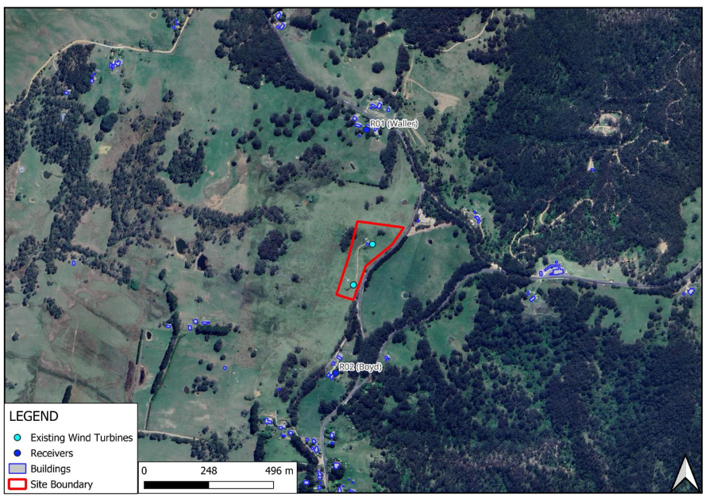  The nearest residential dwellings are located at 119 Hampton Road and Hampton Post Office Road.  Council has received insufficient information from the applicant to assess the potential noise impacts to the area.
Natural Environment | Council has received insufficient information from the applicant to assess the potential impacts to the natural environment.
Social and Economic Impact | Council has received insufficient information from the applicant to assess the potential social and economic impacts to the area.
Natural hazards | The site is affected by bushfire. Grassland management is required on-site and in the immediate vicinities of the turbine positions and above ground infrastructure.  This would be conditioned on the consent and be implemented prior to operation of the two new turbines should the application be recommended for approval.  The primary method of vegetation management is anticipated to be controlled grazing, which has been the historic successful method of vegetation management.
Heritage | The village contains numerous residential uses, Anglican Church, Hampton Public School and local heritage items such as The Stone Cottage, Hampton Road House, cottages. The Hampton Halfway Hotel/Motel is located to the east of the site. This is also a local heritage listed item.  Given the outstanding information, not being submitted to date, Council is unable to determine the potential heritage impacts of the area.  Figure 8: Aerial Image of the development site showing the surrounding heritage items,2025  Jenolan Caves Road  Jenolan Caves Road  Local Heritage Listed Item-Hampton Road House & Cottage  Hampton Village  Local Heritage Listed Item-The Stone Cottage  Local Heritage Listed Item-Cottage  Hampton Road  Sydney via Lowther & Good Forest  Lithgow  Oberon Via Tarana  Oberon  Hampton Halfway Hotel/Motel  Development  Site
Aboriginal Cultural Heritage | There are no recorded heritage sites identified within the development locality under the Aboriginal Heritage Information Management System (AHIMS).  The development is located on a ridge, where groundcover is sparse. The property contains no history of Aboriginal sites being present nor does it contain any significant topographic features. On the basis of the existing development and the absence of any formations where site might usually be expected, the development would have no impact on Aboriginal heritage relics or sites.  Should any objects be found during the construction and excavation works, mitigation and management strategies will be incorporated as conditions in the consent should the application be approved.
Biodiversity | Council has received insufficient information from the applicant to assess the potential biodiversity impacts to the area.

  - Section 4.15(1)(c) - Suitability of the site

Council has received insufficient information from the applicant to assess whether the site is suitable for the proposed new turbines being at a higher elevation to the existing turbines.

  - Section 4.15(1)(d) - Public Submissions

These submissions are considered in Section 4 of this report.

  - Section 4.15(1)(e) - Public interest

Council is unable to state that the development is in the public interest as it has not been demonstrated that the proposal will not have a neutral or beneficial impact on water quality, noise impacts, visual impacts, traffic impacts, heritage, biodiversity and health and safety impacts.

- REFERRALS AND SUBMISSIONS

  - Agency Referrals and Concurrence

The development application has been referred to various agencies for comment/concurrence/referral as required by the EP&A Act and outlined below in Table 4.

Table 4: Concurrence and Referrals to agencies
Agency | Concurrence/  referral trigger | Comments  (Issue, resolution, conditions) | Resolved
Concurrence Requirements (s4.13 of EP&A Act)
Water NSW | Section 6.5 of the Biodiversity and Conservation SEPP (Chapter 6 - Sydney Drinking  Water Catchment) | Water NSW requests additional information to be provided with the application to enable an adequate assessment of the probable effect of the development on water quality. In accordance with the concurrence requirements of the SEPP and section 52 of the Environmental Planning and Assessment Regulation 2021, Water NSW requests that Council obtain from the applicant sufficient information to enable Water NSW to undertake a neutral or beneficial effect (NorBE) on water quality assessment for the development. (WaterNSW letter dated 22 December 2025). | No
Referral/Consultation Agencies
Transport for NSW | Section 2.22 - State Environmental Planning Policy (Resources and Energy) 2021 | The information provided in the Statement of Environmental Effects does not demonstrate that the proposal has mitigated the traffic safety, efficiency and risks to TfNSW assets on the State road network. TfNSW therefore requests additional information relating to the key issues identified in their letter dated 28 November 2025 be obtained. | No
Endeavour Energy | Section 2.48 – State Environmental Planning Policy (Transport and Infrastructure) 2021 Development near electrical infrastructure | Endeavour Energy has advised that the proposal is satisfactory subject to conditions. Refer to response received 11 October 2024. | Yes
Rail authority | Section 2.97 – State Environmental Planning Policy (Transport and Infrastructure) 2021  Development land that is in or adjacent to a rail corridor. | Council referred the application to Sydney Trains due to the impacts of crossing the railway lines during transportation.  Sydney Trains advised that they are not the rail authority in this regard.  A referral to the appropriate Rail Authority has not been undertaken, pending additional information from the applicant in relation to transport and traffic. | No
Civil Aviation Safety Authority | Clauses 139 and165 of the Civil Aviation Safety Regulations (CASR) 1998. | The development was referred to the Australian Civil Aviation Safety Authority who have no objection to the application subject to conditions be placed on the consent. (Response received 28 October 2025). | Yes
NSW Police |  | The development was referred to the NSW Police who have no objection to the CPTED component of this application. Proposed changed are not going to impact differently on what is already in place. (Response received 18 December 2025). | N/A
Nepean Blue Mountains Local Health District |  | To date no response has been received from Nepean Blue Mountains Local Health District. | No
Environmental Protection Authority (EPA) | Chapter 3 Environment protection licences  - Clause 43 - Types of licences  Environment protection licences may be issued for the following purposes—  (b) to authorise the carrying out of scheduled activities at any premises, as required under section 48,  - Clause 48 - Licensing requirement—scheduled activities (premises-based)  (1) Application of section This section applies to scheduled activities where Schedule 1 indicates that a licence is required for premises at which the activity is carried on.  Schedule 1 Scheduled activities  1 Application of Part  For the purposes of section 48, any activity that is declared by this Part to be a scheduled activity is taken to be an activity for which a licence is required for the premises at which it is carried out (the activity is premises-based).  17 Electricity generation  (1) This clause applies to the following activities—  electricity works (wind farms), meaning the generation of electricity by means of wind turbines. | The development was referred to the EPA who advised that they have no comment on the proposal, as it does not appear to constitute a Scheduled Activity under the Protection of the Environment Operations Act 1997, nor would the EPA be the appropriate regulatory authority for matters under the POEO Act.  This is because the proposal for replacement of 2 wind turbines does not appear to be:  - Carried out before 1 Dec 2012 with capacity to generate more than 30MW,  - Subject to an approval under Div 5.2 of the EP&A Act,  - Subject to an approval granted under Part 3A (when in force),  - Subject of a consent relating to SSD,  - By a proponent who is a public authority or network operator,  - On a site regulated under the CLM Act. | N/A

  - Other Referrals

The development application has been referred to various other departments and officers for technical review as outlined in the Table below:

Department | Comments | Resolved
Oberon Council | Oberon Council requested the following additional information on 14 November 2025:  - The O’Connell Avenue of Trees- draft heritage item in Oberon LEP2013 and Heritage Conservation Area – No heritage assessment provided.  - Transport Route- Landowners Consent not provided to utilise O’Connell and Duckmaloi Roads. | No
Mid-Western Council | Mid-Western Council requested the following additional information on 14 November 2025:  - Transport Management Plan- A comprehensive Plan is to be submitted to address traffic impacts, with specific consideration outlined within their submission,  - Consultation with Mid Western Council by the proponent should be undertaken.  - The Council does not support the transportation of large wind turbine vehicles through Mudgee, due to:  -disruptions and impacts on the local road network, including heritage and structural features within the road reserve, and community safety. | No

  - Council Officer Referrals

The development application has been referred to various Council officers for technical review as outlined Table 5.

Table 5: Consideration of Council Referrals
Officer | Comments | Resolved
Engineering | Council has received insufficient information from the applicant to assess the potential impacts against access, traffic and parking. | No
Building | Council has received insufficient information from the applicant to assess building impacts. | No
Waste Officer | Council’s Waste Officer reviewed the submitted documentation and considered that there were no objections to the application. | Yes
Natural Area Management | All likely environmental impacts have not been assessed, therefore the application does not satisfy the requirements of the Environmental Planning and Assessment Act 1979 (EP&A Act).  While the land use is not proposed to change, the biodiversity impacts have increased from the previous approval and require additional assessment under the NSW EP&A Act, Biodiversity Conservation Act 2016 (BC Act) and Federal Environmental Protection and Biodiversity Conservation Act 1999 (EPBC Act). This is due to additional land clearing, larger turbines and increased noise impacts.  It is noted that the low number of species records on NSW Bionet Atlas may indicate that the locality is data deficient, therefore surveys will be required to rule out threatened species presence unless a qualified ecologist can provide evidence of the absence of suitable habitat.  As such, development consent cannot be issued at this time. | No

  - Community Consultation

The development was publicly notified in accordance with the Lithgow Community Participation Plan 2020 (CPP) and the provisions of Environmental Planning and Assessment Regulations 2021 (EP&A Regulation). The notification period was for a minimum of 28 days (extended for an additional 7 days) from 17 October 2025 to 21 November 2025.
During the notification period ninety six (96) submissions by way of objection and three (3) in support were received during the notification period. Additionally, two submissions were received from neighboring Councils.
The key issues involve:
- Tourism Impacts,
- Health and Safety Impacts,
- Legislation Requirements,
- Decommissioning, Rehabilitation and Waste Impacts,
- Biodiversity and Ecological Impacts,
- Benefits and Economic Impacts,
- Property and Business Devaluation,
- Transmission Line Location and Grid Capacity,
- Heritage and Indigenous Impacts,
- Limited Consultation and Transparency with the community,
- Traffic Impacts,
- Current Turbine Issues.
The applicant submitted a GIPA request to Council and received all submissions (redacted privacy information) to address the community concerns raised.

The issues raised in these submissions are considered in the Table below:

Table 6: Community Submissions

Community Concern | Applicants Comments | Council Comments
Inadequate Documentation | The applicant has prepared a register for the issues raised by the community, and to ensure these concerns are adequately address. It should be noted that some of these issues have been dealt with already, not planning  considerations or will be included in elements of the above-mentioned work to be completed. | Council has received insufficient information from the applicant to assess the potential community impacts.
Noise and Vibration
Visual and Amenity Impacts
Tourism Impacts
Health and Safety Impacts
Legislation Requirements
Decommissioning, Rehabilitation and Waste Impacts
Biodiversity and Ecological Impacts
Benefits and Economic Impacts
Property and Business Devaluation
Transmission Line Location and Grid Capacity
Heritage and Indigenous Impacts
Limited Consultation and Transparency with the community
Traffic Impacts
Current Turbine Issues

- KEY ISSUES
The following key issues are relevant to the assessment of this application having considered the relevant planning controls and the proposal in detail:

  - Visual and Amenity Impacts
The proposed turbines would be approximately 1.6 times the height of the existing ones. This equates to 120m overall including blades.

Council assessed the submitted visual assessment to be inadequate and required it to be updated to include the following:

- Compliance with the Wind Energy Guideline November 2024, Department of Planning, Housing and Infrastructure; including:
- Shadow flicker and light pollution,
- address any potential impacts from public places, adjoining landowners/residences and visual prominent places such as look out points.
- Verified ground level,
- Impacts and assessment to surrounding development, infrastructure heritage, skyline and environment,
- Photomontages to involve focal length and viewer height,
- Overshadowing Impacts.

Council has received insufficient information from the applicant to enable appropriate assessment of the potential visual and amenity impacts.

  - Noise and Vibration
The noise assessment submitted with the application is not satisfactory and is to be amended to include the following:

The submitted noise assessment relies on a comparison with to the existing turbines. The noise assessment is to be re-assessed and is to consider the surrounding environment and be in compliant with the Environmental Protection Authority (EPA) Guidelines and the Wind Energy Guideline - Technical Supplement for Noise Impact Assessment.

The revised Noise Assessment is to also include the following:
- Noise modelling in the DA shows levels above this EPA limit (i.e. 42–46 dB(A). Noise mitigation measures are to be detailed to ensure compliance with the EPA Noise Guidelines.
- Assessment of Low-frequency noise pathways and infrasound is to be undertaken, specifically detailing effects on human health and sleep.
- Baseline monitoring and wind speed,
- Adequate monitoring timeframes (i.e. longer then 1hr as per the current noise assessment) and night time stability assessment,
- The current noise assessment contains incomplete source data including sound power data level, frequency data and contradictions regarding rotor diameter and hub height.
- The assessment is to assess special audible characteristics, amplitude modulation,
- The assessment is to include proposed mitigation strategies that commits to specific compliance criteria, detailed testing methodology, and corrective action procedures if non-compliance is measured.
- Background Noise monitoring is to be undertaken at dwelling locations.
- The claim that the proposed Vestas V80 2 MW turbines would be only “2 dB” louder than the existing V47 660 kW turbines is not credible. The increase in hub height (47 m to 80 m), overall height (73 m to 120 m), rotor-swept area (nearly tripled), and generating capacity makes such a conclusion technically unsound. The modelling also fails to account for turbulence, wake effects, nocturnal inversion, and topographic shear.

Council has received insufficient information from the applicant to enable appropriate assessment of the potential noise and vibration impacts.

  - Health and Safety Impacts
Council requested additional information in relation to health and safety impacts.

Given the outstanding information, not being submitted to date, Council is unable to determine the potential impacts.

  - Decommissioning, Rehabilitation and Waste Impacts
Council requested the following further information:

- Council seeks clarification relating to the lifespan of the proposed turbines as Council has concerns relating to financial, bonding, evacuation requirements and infrastructure.

- A detailed decommissioning plan is to be submitted outlining how the development will be decommissioned, what components/infrastructure of the development will be removed, excavation and fill requirements, financial stability, rehabilitation etc.

- A Rehabilitation Plan is to be submitted with the application.

Council has received insufficient information from the applicant to enable appropriate assessment of the potential impacts.

5.5 Biodiversity and Ecological Impacts
The following clarifications and/or amendments are required:
- Detailed mapping of all construction footprints and vegetation clearing, including temporary construction facilities, tracks, stockpile areas and services. This must include worst-case scenario clearing for roadside vegetation along the transport route. The total amount of vegetation to be cleared and trimmed is to be calculated and provided.

- The measures taken to avoid and minimise biodiversity impacts.

- Clarify if the report author processes a Bionet Sensitive Data License and that the database records for birds and bats provided are not denatured.

- A Flora and Fauna Assessment Report (FFA) is to be prepared by a qualified ecologist to address:
- Site biodiversity assessment including;
- Survey and mapping vegetation within the subject land, identification of plant community types and any threatened ecological communities is present.
- Habitat suitability of threatened species within the subject land, and if likely to occur adequate survey undertaken using best practice methods.
- Impact assessment including;
- Direct and indirect impacts on native vegetation and threatened species and their habitats.
- Direct and indirect impacts to species sensitive to wind turbines, including raptors.
- Noise impacts to local wildlife.
- Mitigation measures to reduce impacts to biodiversity during construction and operation

- The FFA must include assessment under part 7.3 of the BC Act for all threatened species and ecological communities listed under the BC Act present or likely to occur within the subject land.

- The FFA must include assessment under the EPBC Act, including likelihood of occurrence of Matters of National Environmental Significance. Assessments using the Significant Impact Criteria listed in the EBPC Act Policy Statement 1.1 (May 2006) for all Matters of National Environmental Significance present or likely to occur within the subject land.

- The FFA must assess impacts to Koalas under the State Environmental Planning Policy (Biodiversity Conservation) - Chapter 3 Koala Habitat Protection 2020.

  - Traffic Impacts
A traffic route study was undertaken and submitted with the application. The study indicates that the development proposes to transport the new turbines from the port at Newcastle through Dunedoo, Mudgee, Bathurst, Oberon and then via Buckmaloi Road and Jenolan Caves Road onto Hampton Road.

The application as such proposes to utilise a mixture of local and state road networks.

The report concluded that the route would require a number of upgrades before it could be deemed suitable for transporting the turbines. This includes bridges, overhead structures/utilities (i.e. rail signals), vegetation and road pavements.

Given the size of the Turbines and the potential impacts resulting to dilapidation, the looping of vegetation along the road reserve and safety on the roads, the application was referred to Transport for NSW for assessment.

Transport for NSW required additional information for assessment of the application. To date this information has not been received.

- CONCLUSION

The application has been assessed under Section 4.15 of the Environmental Planning and Assessment Act 1979 based on information received to date, and is recommended for refusal as:

- Concurrence has not been granted by WaterNSW.
- The applicant has been unable to provide the required information to demonstrate that the proposal meets the NorBE guidelines as required by Sections 6.6 and 6.61 of State Environmental Planning Policy (Biodiversity and Conservation) 2021.
- Council is unable to state that the proposal is of minimal environmental impact in relation to the impact on water quality.
- The applicant has been unable to provide the required information to demonstrate that the proposal meets the Environmental Protection Authority (EPA) Guidelines and the Wind Energy Guideline - Technical Supplement for Noise Impact Assessment.
- The applicant has been unable to provide the required information to demonstrate that the proposal meets the Wind Energy Guideline November 2024, Department of Planning, Housing and Infrastructure.
- The applicant has been unable to provide the required information to demonstrate that the proposal meets Part 7.3 of the Biodiversity Conservation Act 2016 or The State Environmental Planning Policy (Biodiversity Conservation) - Chapter 3 Koala Habitat Protection 2020.
- The applicant has been unable to provide the required information to demonstrate that the proposal meets Transport for NSW requirements as per Roads Act 1993 (Roads Act).
- The applicant has been unable to provide the required information to demonstrate that the proposal meets the State Environmental Planning Policy (Resilience & Hazards) 2021, Chapter 4 Remediation of Land.
- Council is unable to state that the development is in the public interest as it has not been demonstrated that the proposal will not have a neutral or beneficial impact on water quality, noise impacts, visual impacts, traffic impacts, heritage, biodiversity and health and safety impacts.
- Council cannot be satisfied that the development satisfies the Lithgow Local Environmental Plan 2014, Clause 2.3 – Zone Objectives and Land Use Table Clause 7.1 – Consideration of earthworks and Clause 7.3 Stormwater Management.
- Council cannot be satisfied that the development will comply with Chapter 8-Clause 8.8 of the Lithgow Development Control Plan 2021 in relation to solar energy & wind farms.

- RECOMMENDATION

That the Development Application DA154/25 for electricity generating facility (solar and wind) at Lot 1 DP1031694, 43 Hampton Road, Hampton NSW 2790 be REFUSED pursuant to Section 4.16(1)(b) of the Environmental Planning and Assessment Act 1979 for the reasons:

- Insufficient information has been provided to address the following legislation:

- The Environmental Planning and Assessment Act 1979 Clause 4.2 Development that needs consent,
- The Environmental Planning and Assessment Act 1979 Clause 4.13 Consultation and concurrence,

- The Environmental Planning and Assessment Act 1979 Clause 4.15 Evaluation,
- Matters for consideration—general
In determining a development application, a consent authority is to take into consideration such of the following matters as are of relevance to the development the subject of the development application—
(a) the provisions of—
(i) any environmental planning instrument, and
(ii) any proposed instrument that is or has been the subject of public consultation under this Act and that has been notified to the consent authority (unless the Planning Secretary has notified the consent authority that the making of the proposed instrument has been deferred indefinitely or has not been approved), and
(iii) any development control plan, and
(iiia) any planning agreement that has been entered into under section 7.4, or any draft planning agreement that a developer has offered to enter into under section 7.4, and
(iv) the regulations (to the extent that they prescribe matters for the purposes of this paragraph),
that apply to the land to which the development application relates,
(b) the likely impacts of that development, including environmental impacts on both the natural and built environments, and social and economic impacts in the locality,
(c) the suitability of the site for the development,
(d) any submissions made in accordance with this Act or the regulations,
(e) the public interest.

- Insufficient information has been provided to address the requirements of the State Environmental Planning Policy (Biodiversity and Conservation) 2021, Section 6.6 Water Quality and Quantity, and Section 6.61 Requirement of neutral or beneficial effect on water quality,

- Insufficient information has been provided to address the requirements of the Biodiversity Conservation Act 2016 (BCAct),

- Insufficient information has been provided to address the requirements of the Roads Act 1993 (Roads Act),

- Insufficient information has been provided to address the requirements of the State Environmental Planning Policy (Resilience & Hazards) 2021, Chapter 4 Remediation of Land,

- Insufficient information has been provided to address the requirements of the Lithgow Local Environmental Plan (LEP) 2014; Clause 2.3 – Zone Objectives and Land Use Table Clause 7.1 – Consideration of earthworks and Clause 7.3 Stormwater Management,

- Insufficient information has been provided to address the requirements of The Wind Energy Guideline November 2024, Department of Planning, Housing and Infrastructure.

(8) Council has received insufficient information from the applicant to enable appropriate assessment of natural hazards, water, social and economic impacts, context and setting and adjoining landuses, and therefore the suitability of the site is unknown.

Based on the reasons provided above, the proposal is not considered to be in keeping with Chapters 2- Site Requirements, Chapter 3 Environmental and Hazards and Chapter 8 Rural & Other Land Uses of the Lithgow Development Control Plan (DCP) 2021.

(9) The application fails to demonstrate the suitability of the site for the proposed development (section 4.15(1)(c) of the EP&A Act).

- The proposal is not considered to be in the public interest, given the lack of information to adequately assess the environmental, social and economic impacts (section 4.15(1)(e) of the EP&A Act).

8. ATTACHMENTS
The following attachments are provided:

- Attachment A: Statement of Environmental Effects
- Attachment B: Built Features Management Plan
- Attachment C: General Specifications
- Attachment D: Noise and Vibration Assessment
- Attachment E: Rotor and Hub Dimension Illustration
- Attachment F: Site Plan
- Attachment G: Site Survey
- Attachment H: Traffic Route Survey Newcastle to Hampton
- Attachment I: Visual Assessment
- Attachment J: DA96-01 Council Approval for existing Turbines
- Attachment K: RFI Response 13 January 2026

